What’s Popping!
Your Guide to the 2020 Popcorn Program
What’s New in 2020  1. Additional Investment in Scout Rewards program to help incentivize your Scouts.  In 2019 NCAC and Trail’s End partnered to provide our Scouts an opportunity to earn a prize of their choice. Scouts can set their sales strategy to earn an Amazon gift card that can be used to the purchase of their own recognition item. In 2020 you will find increased rewards and additional levels to provide more recognition opportunities for your families.  2. Redesign of Trail’s End website and mobile app  Trail’s End launched the mobile app and a new Unit Leader/Parent Portal in 2019. 2020 will show a simpler and more user friend system along with a direct link to the online platform that will increase product line up and options at store fronts and door to door sales.  3. Storefront sign up.  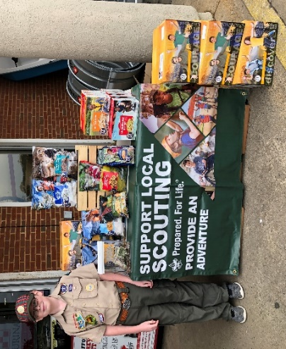  NCAC and Trail’s End will be partnering to create storefront opportunities. By coordinating through Trail’s End, units will be able to select available storefront shifts direct from their unit leader portal. Our goal is to provide 30,000 hours of direct storefront shifts to our units by partnering with local grocery stores, big box stores, and your traditional storefront locations. Unit will still have the ability to add local/unique locations to their schedule. | Why participate in the Program in 2020  1. Simple to Run & Minimal Risk.  Trail’s End Popcorn has been a trusted fundraising program for over 30 years. A turn-key program, with no up-front money required. Units receive Council and District support throughout the sale and beyond. Units can return up to 10% of product, reducing the risk of being “stuck” with popcorn.  New Units in 2020 have ZERO financial risk.  2. Support your unit and NCAC in a single fundraiser.  The average NCAC unit sale is about $10,000. Our commission structure would provide $3,500 to support your units financial needs while also providing about $2,800 to support NCAC programs, properties and operating costs. Your success is NCAC success and we are here to help you raise your goal.  3. Participating in the Popcorn Program can provide advancement opportunities and learn valuable skills.  There are requirements in at least 13 Merit Badges that can be completed through the Popcorn Program. For example, Eagle-required badges like Personal Management and Communication have requirements that can use the sale as well as Public Speaking. The Salesmanship Merit Badge can be completed using the Popcorn Program. For example #5a: “Help your unit raise funds through sales of merchandise or of tickets to a Scout event.” Or #3: Write and present a sales plan for a product or service and a sales territory assigned by your counselor.  American Business Merit Badge requirement #5: “Run a small business involving a product or service for at least three months. First find out the need for it. ... Keep records showing the costs, income, and profit or loss.”  4. No upfront costs and commission incentive to try the sale.  Units will order their inventory online, then through their District Popcorn Rep or Executive, develop a sales strategy. This can include storefront sales, wagon sales, take order sales, and online Sales. Payment on product sold is due in November at the completion of the program. New units can earn bonus commissions to give the Popcorn Program a try.

