Announcing the Annual Catholic Scout Retreat:

St Mary’s Birthday
8 September 2018

Join us for a day of Scout fun!
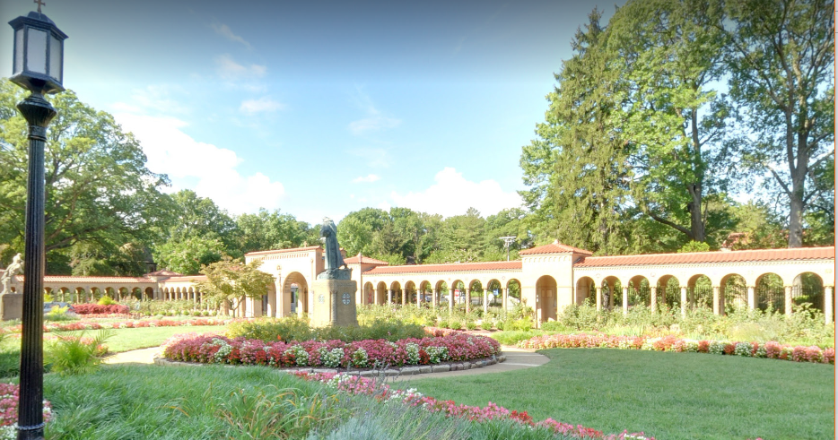
Going to the Holy Land in the
United States!
Registration Fee $10/person
“Very well put together”

“Inspirational”

“Fun”
“I loved it!!!”
“Awesome”
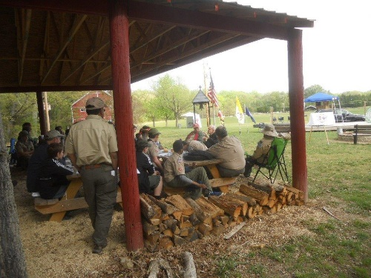

Sponsored by:
The Catholic Committee on [Boy] Scouting, Archdiocese of Washington

Developed by Scouts for Scouts Living the 12th Point of the Scout Law
Franciscan Monetary
1400 Quincy St NE
Washington, DC 20017

The retreat is primarily for Scouts from the National Capital Area Council, but is open to all Boy Scouts and members of Venturing Crews from other councils as well. We are also inviting Trail Life, American Heritage Girls and Girl Scouts – members who are ages 11-18. Activities begin Saturday morning with registration at 7:30 am. All youth will participate in a variety of activity stations. Holy Mass will be offered Saturday evening (fulfills Sunday obligation). Saturday activities will include a Penance Service, Stations of the Cross, Rosary Walk, Monastery Tour, Scavenger Hunt, Prayer Lilies and Field Games. Youth will also have the opportunity for Chaplain’s Aide training. All activities are coordinated to allow troops and crews to attend the event and camp as a unit, as they do at other Scouting camporees. The retreat concludes Saturday evening after dinner and night prayers. Please see the draft schedule on page 3 for more information.

Registration, Child/Youth Protection, and Logistics

Registration:
- Registration fee of $10.00 per attendee (adult or youth) is payable onsite (make checks payable to the Catholic Committee on Scouting). Saturday Lunch and Dinner will be provided by the Retreat staff. A retreat patch with year rocker and Immaculate Conception Patch will be provided to participants. The Glorious Mysteries Rosary Patch can be purchased by the units from NCCS. Please pre-register with an estimate of the number of participants to assist us in purchasing supplies. Overnight camping is available for Friday or Saturday night for no additional charge. All meals other than Saturday Lunch and Dinner must be provided by the unit.

- All retreat attendees must be listed on the unit roster at check-in and must provide the appropriate BSA health and medical record, please ensure the forms have phone numbers where parent/guardian can be reached during the weekend.

- All participants must turn in a completed Archdiocesan Office of Youth Ministry permission form. These consent forms will not be returned.

- Please direct registration questions to Trish Walker (301-498-3071, walkerscouts@verizon.net) or Dottie Tamai (301-773-1995, dtamai14@gmail.com).

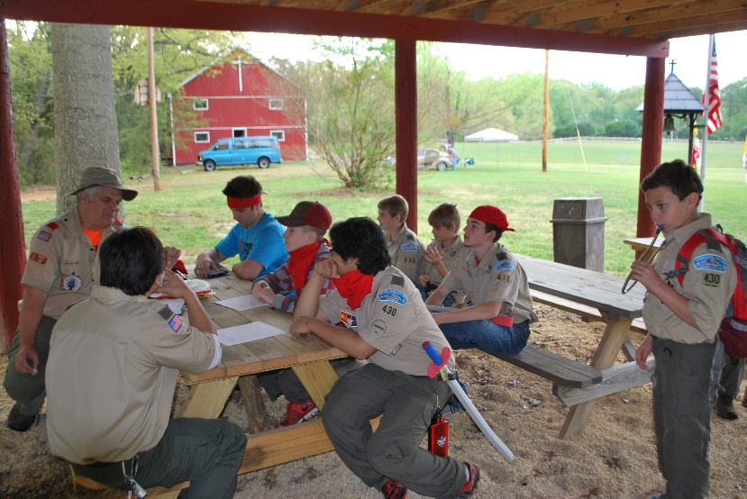
Child and Youth Protection Requirements:
All adults present during the retreat MUST have completed the appropriate Child/Youth Protection program. A statement from the Chartered Organization Representative on organization letterhead or copies of the certificates of completion must be provided no later than check-in. Adults affiliated with Catholic chartered units are encouraged to provide names of potential adult attendees to the registrars prior to the retreat to facilitate the onsite check-in and verification process.
Please see the Catholic Committee on Boy Scouting Program Book or contact the registrars for more information.

Camping:
- We have promised the Franciscan Monastery that as Scouts, we will “leave no trace”. It is imperative that all areas be left in the same or better condition than they were at our arrival. All trash must be packed out.

- Scouts will camp with their unit. Units will provide their own meals (other than Saturday Lunch and Dinner). No ground fires are permitted in camp sites. Trailers can be unloaded on the access road, after which the vehicle must be immediately removed to the parking area.

- Only metal stakes will be permitted in sites, no wooden stakes or anything else that will damage the manor house grounds will be allowed.

Other Helpful information:
- Weather can be unpredictable, please remember rain gear, warm clothing and sunscreen may be necessary.
- Past attendees have found it helpful to bring a camp chair and flashlight or head lamp.
- Please label all items. Lost and Found will be located at the First Aid tent.
- Attendees are encouraged to leave the electronics at home. If they are brought to the retreat, we ask they remain off except in case of emergency.
- Please refrain from activities that make noise, create odors, or in any manner detract during religious services/liturgies, Penance Service, Adoration, etc. This includes: cooking; games; and service projects.

Medical Matters:
- Attendees with prescriptions for inhalers, epi-pens, or other “rescue medications” are to keep these medications with them at all times during the weekend.

- Volunteers will be onsite to assist with health related emergencies. Care will be limited to basic first aid. No medications will be available from these volunteers.

- Attendees who require medical equipment (e.g., CPAP, nebulizers) must provide their own power (e.g., battery supply) for the devices. Vehicles may not be brought into the camping area to provide power.

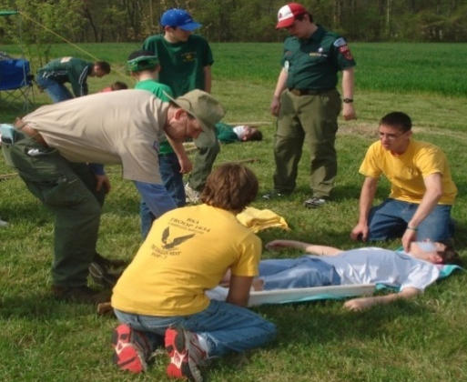
Tentative Schedule - Units will be provided with final schedule in a program book at the retreat.

Friday, September 7, 2018 (Optional Overnight Camping
7:00-9:00 Optional Registration / Camping

Saturday, September 8, 2018
8:00 – 9:00 Registration
9:00 – 9:50 Opening Ceremonies / Rosary Walk / Glorious Mysteries Rosary Patch
10:00 – 10:55 Session One / Tour
11:00 – 11:55 Session Two / Tour
12:00 – 1:00 Lunch
12:30 – 1:45 Penance Service (Grotto) and Confessions in Church
12:30 - 2:00 Chaplain’s Aide Training (register at check-in if attending)
1:00 – 02:00 Free Time – take a reflective walk around the Retreat center
2:00 – 2:50 Via Crucis
3:00 – 3:50 Session Three / Tour
4:00 – 4:20 Immaculate Conception Patch
4:20 – 4:45 Which Way Do I Go? and Why do they do what they do?
4:45 – 6:00 Closing Mass (In the Church)
6:00 – 6:45 Dinner
6:45 – 7:00 Closing Night Prayers
8:15 – 10:00 Optional Informal Campfire

Sunday, September 9, 2018 (Optional Overnight Camping)
10:00 All campsites packed-up and headed home

Questions:

- Scout Units and Venturing Crews please contact Trish Walker (301-498-3071, walkerscouts@verizon.net) or Dottie Tamai (301-773-1995, dtamai14@gmail.com)

- Priests, Religious, and seminarians please contact Rev. Scott Woods (301-862-4600)

- Adults interested in helping before or during the retreat should contact Dick Stevick (dstevick@verizon.net)

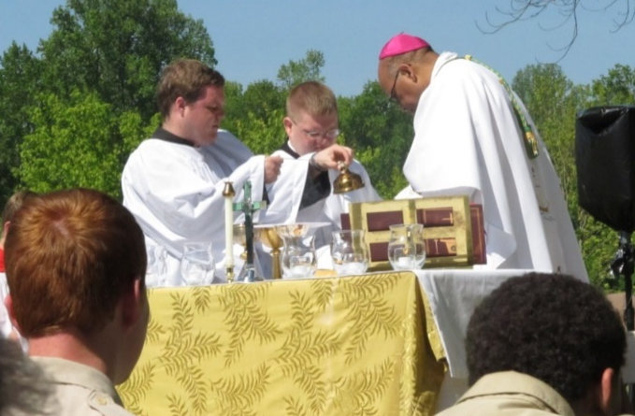 | The Franciscan Monastery is  About 50 min from Silver Spring MD  About 45 min from Fairfax VA  About 90 min from St Mary’s City MD  Registration is to the left as you go through the entrance portico.  Addresses  Parking: 3970 14th St NW, Washington, DC 20017  Camping Entrance: 3999 14th St NW, Washington, DC

Site Number:
For Retreat Registration Use

2018 CATHOLIC SCOUT RETREAT REGISTRATION FORM
(Please Print)

Boy Scout / Trail Life USA / Girl Scout / American Heritage Girls / Camp Fire USA
Unit ____________________________ District: __________________________
Venturing Crews: Male youth _____ Female youth _____

Unit is chartered to: _______________________________________________________
City: _______________________________________________________
Unit Contact Person: _______________________________________________________
Position in the Unit: _______________________________________________________
Mailing Address: _______________________________________________________
_______________________________________________________
City, State Zip Code: _______________________________________________________
Phone Number: Day:_____________________ Evening:______________________
Cell Phone:________________________________
E-mail Address: _______________________________________________________
There are no trailer sites. Can be parked fairly close but will have be unloaded and moved.
Venturing Units please contact Dottie Tamai or Trish Walker before submitting this form.

Estimated Number of Catholic attendees: Youth: _____ Adult: _____
Estimated Number of Protestant attendees: Youth: _____ Adult: _____
Estimated Number of attendees of other faiths: Youth: _____ Adult: _____
Estimated Number of first time attendees: Youth: _____ Adult: _____

Estimated Number of attendees Camping: Friday: _____ Saturday: _____
Number of Youth attending Chaplain’s Aide Training: __________
Number of Adults attending Catholic Boy Scout Catholic Emblem Training: _________
Are all Adults compliant with the Arch/diocesan Child Protection Policy or BSA Youth Protection? ___

Mail to:
Dottie Tamai
2107 Kent Village Drive
Landover, MD 20785
(301) 773-1995

Or e-mail to:
Trish Walker
walkerscouts@verizon.net
301-498-3071
(e-mail deadline 03 Sep 2018)
Annual Catholic Scout Retreat 8 Sep 2018
Unit Roster for ________ at site _____
(submit on arrival to camp)
Youth Name |  | H | O |  | Youth Name |  | H | O
1 |  |  |  |  | 21
2 |  |  |  |  | 22
3 |  |  |  |  | 23
4 |  |  |  |  | 24
5 |  |  |  |  | 25
6 |  |  |  |  | 26
7 |  |  |  |  | 27
8 |  |  |  |  | 28
9 |  |  |  |  | 29
10 |  |  |  |  | 30
11 |  |  |  |  | 31
12 |  |  |  |  | 32
13 |  |  |  |  | 33
14 |  |  |  |  | 34
15 |  |  |  |  | 35
16 |  |  |  |  | 36
17 |  |  |  |  | 37
18 |  |  |  |  | 38
19 |  |  |  |  | 39
20 |  |  |  |  | 40

Adult Name |  | (staff use only) |  |  | Adult Name |  | (staff use only)
 |  | H | O | Y |  |  | H | O | Y
1 |  |  |  |  | 8
2 |  |  |  |  | 9
3 |  |  |  |  | 10
4 |  |  |  |  | 11
5 |  |  |  |  | 12
6 |  |  |  |  | 13
7 |  |  |  |  | 14

Youth Names for Chaplain’s Aide Training
1 |  | 2

All participants must have a copy of the appropriate medical form. All adults must provide evidence of completion of Arch/diocesan Child Protection program or BSA Youth Protection training at registration.

Catholic Committee on Scouting

Office of Youth Ministry/Catholic Youth Organization

Archdiocese of Washington

Release and Consent - Youth

I, _________________________________________________ the undersigned, give permission for my child _________________________________________ to attend the 2018 Catholic Scout Retreat at the DC Franciscan Monastery. It is understood that reasonable caution will be taken by those persons in charge to prevent injuries. In consideration of my child’s being permitted to participate in the 2018 Catholic Scout Retreat; I personally, and on behalf of my child, hereby release the Catholic Committee on Scouting/The Archdiocese of Washington; Archbishop Donald Cardinal Wuerl, Roman Catholic Archbishop of Washington; a Corporation Sole: the Catholic Youth Organization (CYO) of Washington, DC and Metropolitan Area, Inc; the Office of Youth Ministry (OYM); the DC Franciscan Monastery; their employees; volunteers, the coordinators and chaperones of the Catholic Committee on Scouting; from any liability for injuries or damages arising or resulting from participation in the 2018 Catholic Scout Retreat. In the event that I cannot be reached, I hereby grant permission for my child to be evaluated, diagnosed, treated and/or medicated in accordance with standard medical practice by licensed medical personnel.

Permission is hereby granted to the Catholic Committee on Scouting, the Archdiocese of Washington, and the DC Franciscan Monastery to use the photographs, videography, and quotations of my son/daughter to assist in community awareness, educational efforts, and related public relations purposes, which may include brochures, posters, website and print media.

________________________________________________________________________
Parent or Legal Guardian signature Date

_____________________________________________________________________________
Parent or Legal Guardian – PRINT NAME

Contact Phone Number: ________________________________________________

Alternate Phone Number: _______________________________________________

Catholic Committee on Scouting

Office of Youth Ministry/Catholic Youth Organization

Archdiocese of Washington

Release and Consent - Adult

I, _________________________________________________ the undersigned, understand that reasonable caution will be taken at the 2018 Catholic Scout Retreat at DC Franciscan Monastery, by those persons in charge to prevent injuries. In consideration of being permitted to participate in the 2018 Catholic Scout Retreat; I personally, and on behalf of my family, hereby release the Catholic Committee on Scouting/The Archdiocese of Washington; Archbishop Donald Cardinal Wuerl, Roman Catholic Archbishop of Washington; a Corporation Sole: the Catholic Youth Organization (CYO) of Washington, DC and Metropolitan Area, Inc; the Office of Youth Ministry (OYM); the DC Franciscan Monastery; their employees; volunteers, the coordinators and chaperones of the Catholic Committee on Scouting; from any liability for injuries or damages arising or resulting from participation in the 2018 Catholic Scout Retreat. I hereby grant permission to be evaluated, diagnosed, treated and/or medicated in accordance with standard medical practice by licensed medical personnel.

Permission is hereby granted to the Catholic Committee on Scouting, the Archdiocese of Washington, and the DC Franciscan Monastery to use any photographs, videography, and quotations to assist in community awareness, educational efforts, and related public relations purposes, which may include brochures, posters, website and print media.

________________________________________________________________________
Attendee Signature Date

_____________________________________________________________________________
PRINT NAME

Contact Phone Number: ________________________________________________

Alternate Phone Number: _______________________________________________

