Amangamek-Wipit
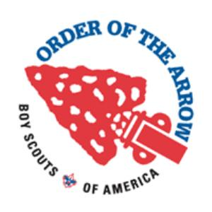
Lodge 470
NLS/DYLC request form
Submission process

- Complete this form
- Print it out and have it signed by your Chapter Adviser
- Submit to the Lodge Training Committee (training@wipit470.org)
- The Lodge Training committee will notify you of their decision
Applicant Information

Applicant’s Full Legal Name:
First _________________ Middle _________________ Last _________________
Badge name:____________________ OALM ID: __________________________
Current Position: _________________ Chapter:___________________________
Date of Birth: _____ /_____ /_______ Gender: □ Male □ Female
Street Address: _____________________________________________________
City:__________________ State: ________________ Zip Code: ______________
Home Phone:____________________ Mobile Phone: ______________________
Dietary Restrictions:
□ None □ No Nuts □ No Shellfish □ Vegetarian □ Other: _________________
Special Needs & Requests:____________________________________________
__________________________________________________________________
National Leadership Summit or Developing Youth Leadership Conference

Course Requested: □ NLS □ DYLC
Age at time of course: ____ □ Youth □ Adult
Course Dates: ___________________ Course Location: ____________________

Chapter Adviser Signature:____________________________________________

Reason for wanting to attend, include future positions:

Applicant Signature: Date:

