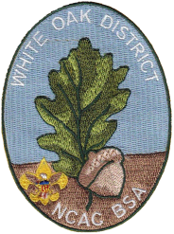

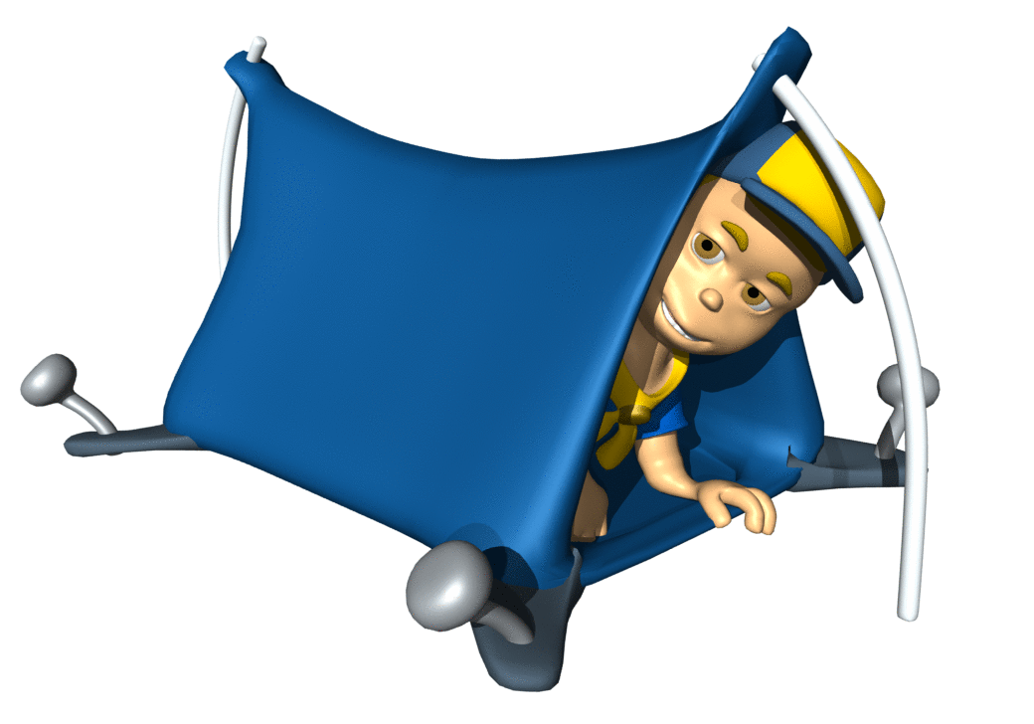 White Oak District

Cub Scout Roundtable

September 2017 Information Sheet

**Scout Law:** Thrifty

**Interest Topic:**  A Camping We Will Go

**Opening Ceremony**

**Cub Scout 1:** “Our Cubmaster has challenged us to find our thriftiest camping tips to share with

our new families for the pack campout.”

**Cub Scout 2:** “I know—they can freeze gallons of water so they don’t have to buy ice for their

coolers.”

**Cub Scout 3:** “They can use tongue-and-groove pliers instead of pot holders, if they already

have them. Those work great.”

**Cub Scout 4:** “We can tell them to shop at garage sales. Mr. Scott got his camp stove at one for just $5.”

**Cub Scout 5:** “We can also suggest they sign up for online alerts for sales on tents.”

**Cub Scout 6:** “Laundry lint makes good tinder for a campfire. My family always takes a plastic

bag of it when we camp.”

**Cub Scout 7:** “They can make waterproof matches by dipping them in clear nail polish.

Remember, Cub Scouts shouldn’t handle matches.”

**Cub Scout 8:** “They can make a box oven to bake food; they won’t need to have a camp stove.”

**Cub Scout 1:** “I think we have great ideas to share.”

**All:** “A Scout is thrifty!”

**The Cub Scout Six Essentials?**

These are items every Cub Scout should carry in his personal gear when going on hikes or campouts:

1. First-aid kit: adhesive bandages, moleskin, gauze, antibiotic ointment, etc.

2. Water bottle: filled and large enough to last until it can be filled again

3. Flashlight: for emergency use only

4. Trail food: can be made as a den activity prior to hike or campout

5. Sun protection: sunscreen of SPF 30 or greater and a hat

6. Whistle: also for emergency use only

**Closing Ceremony**

**Cub Scout 1:** “We like camping, and we think it is fun.”

**Cub Scout 2:** “We know we can be thrifty when we camp.”

**Cub Scout 3:** “We don’t put food in our tents; it attracts animals.”

**Cub Scout 4:** “We practice obeying all of the rules of the campfire.”

**Cub Scout 5:** “We are looking forward to our next campout.”

**Cub Scout 6:** “We hope that you will join us for more camping fun.”

**Cub Scout 7:** “We love camping.”

**Cub Scout 8:** “See you at our next campout.”

Upcoming Important Dates (see WODSRT emails for more and details):

* Sep 13 - Cub Scout Roundtable
* Sep 16-17 - STEM Family Camping @ Camp Snyder
* Sep 16 - CS Leader Training (Herndon VA)
* Sep 16 - Lion Guide/Parent Training (Herndon VA)
* Sep 16 - BALOO Training (Catlett, VA)
* Sep 20 - Join Scouting Night
* Sep 23 - New Member Application Turn-in
* Oct 21 - Cub Scout Leader Training
* Oct 27-28 - Webelos Weekend
* Oct 27 - Tiger Hunt & Lion Roar
* Nov 4 & 11 - Scouting for Food bag distribution & pickup
* Nov 18 - Rechartering turn-in – 1st opportunity

Resources:

District WebPage – <http://www.ncacbsa.org/white-oak/>

District Facebook -- <https://www.facebook.com/WhiteOakDistrict/>

Training and Tools - <https://my.scouting.org>

Baloo’s Bugle - <http://usscouts.org/bbugle2016-2017.asp>

BSA Cub Scout page – <https://cubscouts.org>

Cub Scout Trax - <http://trax.boy-scouts.net/cubtrax.htm>

Pack Meeting Plans - <http://www.scouting.org/Home/CubScouts/Leaders/CubmasterResources/PackMeetingPlans.aspx>

Rank Requirements Addendums (2017) –

Tiger - <http://www.scouting.org/filestore/cubscouts/pdf/Tiger_Addendum.pdf>

Wolf - <http://www.scouting.org/filestore/cubscouts/pdf/Wolf_Addendum.pdf>

Bear - <http://www.scouting.org/filestore/cubscouts/pdf/Bear_Addendum.pdf>

Webelos/AOL –

<http://www.scouting.org/filestore/cubscouts/pdf/webelos_aol_Addendum.pdf>

Contacts:

Cub Scout Roundtable Commissioner - Jeffrey Cohen – [jcohen@troop613](mailto:CSRoundtable@WhiteOakDistrict.Org).com

District Commissioner – Mike Holder - [thedukeholder@verizon.net](mailto:thedukeholder@verizon.net)

District Chairman – Bill Totten - [wandst@juno.com](mailto:wandst@juno.com)

District Executive – Stephen Donnelly - [stephen.donnelly@scouting.org](mailto:stephen.donnelly@scouting.org)

**CAMPSITE CONSIDERATIONS**

Cub Scout camping will take place in sites approved by the local council (council camps, local

parks, campgrounds), so some choices may be limited, but there are still several considerations

to keep in mind when laying out your campsite for a pack event.

• Location. A campsite facing the south or southeast will get more sunlight and generally will be drier than one on the north side of a hill or in the shade of mountains or cliffs. Cold, damp air tends to settle, causing the bottoms of valleys to be more cool and moist than locations a little higher. On the other hand, hilltops and sharp ridges can be very windy and should be avoided in lightning-prone areas.

• Size and shape. A good campsite has plenty of space for your tents and enough room to conduct your activities. It should be usable as it is, so you won’t need to do any digging or major rock removal to shape the area. The less rearranging you do, the easier it will be to follow Leave No Trace principles and leave the site exactly as you found it.

• Protection. Consider the direction of the wind and the direction from which a storm will approach. Is your campsite in the open or is it protected by a hill or a stand of trees? Is there a solitary tree nearby that may attract lightning? Don’t camp under dead trees or trees with dead branches that may come down in a storm or light wind. The best campsites are found near small, forested ridges and hills.

• Insects and animals. All creatures have their favorite habitats. The best way to avoid mosquitoes and biting flies is to camp away from marshes, bogs, and pools of stagnant water. Breezes discourage insects, so you might look for an elevated, open campsite. Don’t forget to check around for beehives, hornet nests, and ant mounds; their inhabitants usually won’t bother you as long as you leave them alone, but give them plenty of room. The same goes for most animals.

• Ground cover. Any vegetation covering a campsite will receive a lot of wear and tear. Tents will smother it, sleepers will pack it down, and walkers will bruise it with the soles of their shoes. Some ground cover is tough enough to absorb the abuse, but much of it is not. Whenever you can, make your camp on naturally bare earth, sand, graveled soil, or ground covered with pine needles or leaves.

• Drainage. While a campsite should be relatively flat, it should slope enough to allow rainwater to run off. However, you don’t want to be in the path of natural drainage. Check uphill from where you plan to set up your tent to make sure water won’t run through the site. Never camp in a stream bed! Also, you want to avoid depressions in the ground, as even shallow ones can collect water in a storm.

• Privacy. One of the pleasures of camping is getting away from crowds and the fast pace of city life. Make camp in places that are far enough away from trails and other campsites. That way you can enjoy peace and privacy while respecting the privacy of other campers.

• Beauty. The beauty of a campsite often is what attracts visitors to it. Being able to look out from a tent and see towering mountains, glistening lakes, or miles of canyon land or rolling prairie is part of what camping is all about. Find a campsite that gives you spectacular scenery, but camp there only if the site is appropriate for every other reason, too.

• Outdoor ethics. Be gentle on Mother Nature. You can do a lot to protect and preserve the wilderness by leaving no trace of your visit, no marks along the trail, and a tidy campsite— cleaner than you found it. Don’t harm plants, animals, or insects. Take nothing but pictures, leave nothing but footprints, and kill nothing but time. That philosophy fits as well in a county park as it does anywhere else.

PACK CAMPING GEAR

In addition to individual equipment, the equipment listed below should be available for group use. 