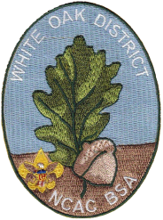

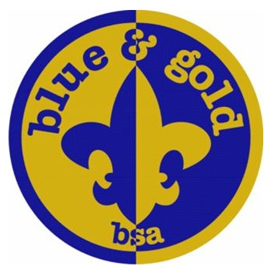 White Oak District

Cub Scout Roundtable

November 2017 Information Sheet

**Main Topics:**

Who owns the unit?

Den/Pack Behavior and Discipline

Blue and Gold Banquet

**Who owns the unit?**

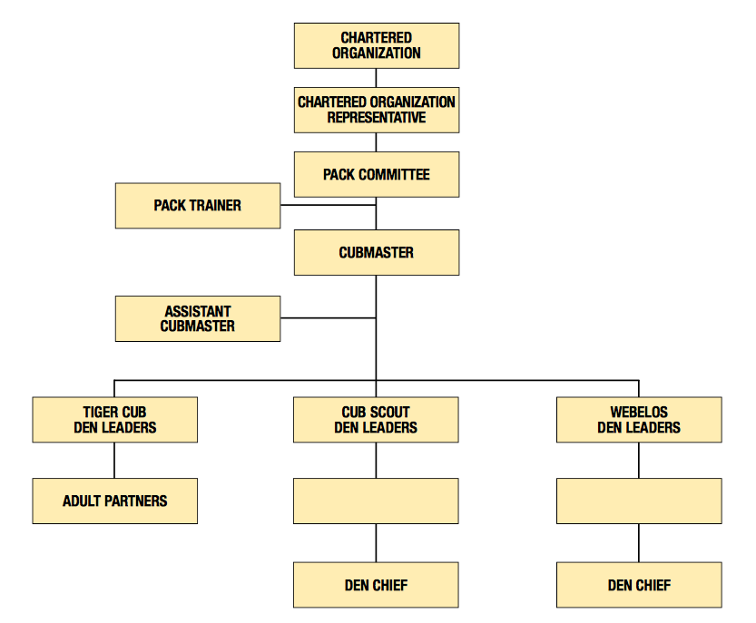

**Den/Pack Behavior and Discipline**

Helpful Hints (from <https://cubscouts.org/library/behavior-and-discipline/> )

1. Use the Cub Scout sign to get attention
2. Keep den and pack meetings fast-paced, and have many interesting activities
3. Try to get to know each boy
4. Behave toward boys impartially, regardless of race, social class, religion, and any other difference
5. Listen attentively and try to understand what is written or spoken
6. Don’t criticize a boy in front of his den or pack; he will feel betrayed and humiliated
7. Focus on the positives and minimize the negatives
8. Give boys opportunities to make choices
9. Provide boys with appropriate challenges
10. Take some extra time to reflect on each meeting and learn from your own experience

**Blue and Gold Banquet –** Suggestedplanning timeline

Two to three months before the blue and gold banquet

Review last year

Confirm/Finalize Date/time & Location

Finalize Budgeting

Decide on high level menu & program

­­

Four to six weeks before the banquet

Send out flyers/invitations

Plan decorations

Invite local Boy Scout Troop(s) for Arrow of Light and crossover/bridging ceremony

Coordinate with Cubmaster on award ceremony and Arrow of Light ceremony

Plan for setup/cleanup

One to two weeks before the banquet

Reconfirm - location, food, and any speaker, special guests, Boy Scout Troop(s), etc.

Send reminder notices via social media and email

Reconfirm setup/cleanup plans

On the day of the banquet

Arrive early with plenty of help to setup

Have FUN!!!

One week AFTER the banquet

Evaluate

Upcoming Important Dates (see WODSRT emails for more and details):

* Nov 11 - Scouting for Food bag pickup
* Nov 18 - Charter Org Rep Training (Oak Hill, VA)
* Nov 18 - Final popcorn distribution
* Dec 8 - Popcorn payments/prize orders/scholarship forms due
* Dec 9 (9a-12noon)- Rechartering turn-in (1st chance)
* Dec 13 - District meeting and Holiday Party
* Dec 16 - Rechartering turn-in (last chance)

Resources:

District WebPage – <http://www.ncacbsa.org/white-oak/>

District Facebook -- <https://www.facebook.com/WhiteOakDistrict/>

Training and Tools - <https://my.scouting.org>

Baloo’s Bugle - <http://usscouts.org/bbugle2016-2017.asp>

BSA Cub Scout page – <https://cubscouts.org>

Cub Scout Trax - <http://trax.boy-scouts.net/cubtrax.htm>

Pack Meeting Plans - <http://www.scouting.org/Home/CubScouts/Leaders/CubmasterResources/PackMeetingPlans.aspx>

Rank Requirements Addendums (2017) –

Tiger - <http://www.scouting.org/filestore/cubscouts/pdf/Tiger_Addendum.pdf>

Wolf - <http://www.scouting.org/filestore/cubscouts/pdf/Wolf_Addendum.pdf>

Bear - <http://www.scouting.org/filestore/cubscouts/pdf/Bear_Addendum.pdf>

Webelos/AOL –

<http://www.scouting.org/filestore/cubscouts/pdf/webelos_aol_Addendum.pdf>

Contacts:

Cub Scout Roundtable Commissioner - Jeffrey Cohen – [jcohen@troop613](mailto:CSRoundtable@WhiteOakDistrict.Org).com

District Commissioner – Mike Holder - [thedukeholder@verizon.net](mailto:thedukeholder@verizon.net)

District Chairman – Bill Totten - [wandst@juno.com](mailto:wandst@juno.com)

District Executive – Stephen Donnelly - [stephen.donnelly@scouting.org](mailto:stephen.donnelly@scouting.org)