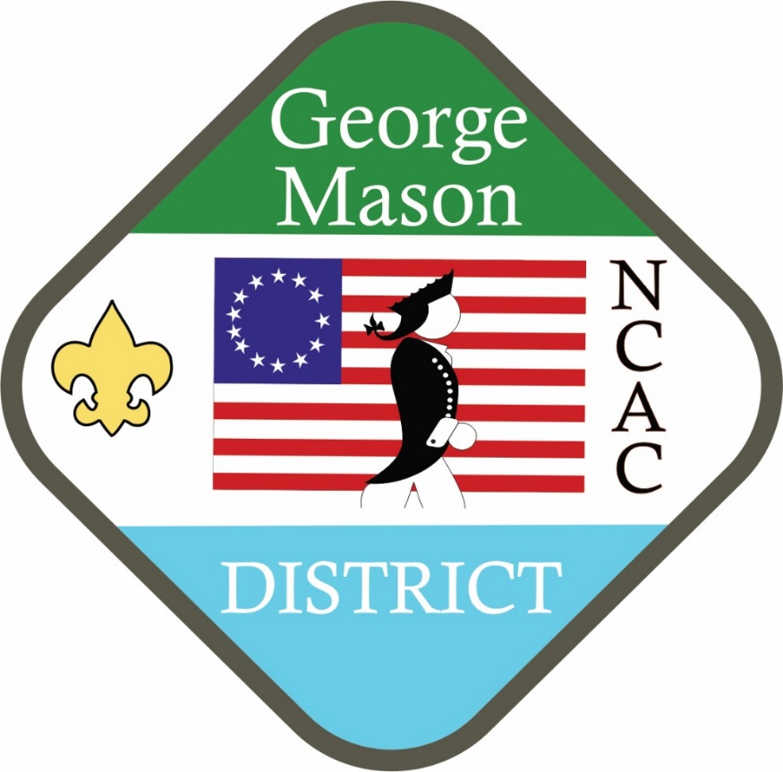

Welcome to this edition of the George Mason District Press. We e-mail this out bi-monthly to the BSA registered leaders in George Mason District; unit leaders and merit badge counselors – those who have their current YPT.

George Mason District Leadership and its youth appreciate all of the hard work and commitment you provide to the youth of our community. Thank you.

Please plan to attend the Thurs. August 11, 2022 –

Roundtable Meeting (Thoreau and online) at 7:30 pm – OA Chapter meeting will be same time/location

USEFUL LINKS:

[NCAC Council Web site](https://www.ncacbsa.org/) [National BSA](https://www.scouting.org)

[GMD Web Site](https://www.ncacbsa.org/george-mason/) [GMD Upcoming Events](https://www.ncacbsa.org/george-mason/mainpage/upcoming-events/district-events-listing/)

[GMD Roundtable (PW: GMDRT)](https://www.ncacbsa.org/george-mason/mainpage/district-resources/roundtable/) [GMD Training](https://www.ncacbsa.org/george-mason/mainpage/training/)

[National Order of the Arrow](https://oa-bsa.org/) [wipit470.org](https://wipit470.org/index.html)

[Pay OA Dues](https://scoutingevent.com/082-52773)

All information about rechartering including fees is updated in the Council’s site:

<https://www.ncacbsa.org/recharter/>

**Calendar of Events – Links included if available**

07/01/22 - New Citizenship in Society Merit Badge required for Eagle Scout

07/09/22 -07/10/22 - [**SCUBA PADI Certification (1 of 2)**](https://www.ncacbsa.org/aquatics-committee/), Pool Session

07/11/22 - 07/15/22 - [**Cub Day Camp**](https://scoutingevent.com/082-DayCamp2022), Camp Snyder, Haymarket, VA

07/16/22 - 07/17/22 - [**SCUBA PADI Certification (2 of 2)**](https://www.ncacbsa.org/aquatics-committee/), Open Water  
07/17/22 - 07/23/22 - [**Scouts BSA Specialty Week (5 Merit Badges)**](https://scoutingevent.com/082-49917), Camp Snyder

07/17/22 - 07/23/22 - [**James River Adventure Crew**](https://www.gotogoshen.org/camps-programs/lenhoksin-high-adventure/), Goshen, VA

07/24/22 - 07/29/22 - [**Course 22-4 National Youth Leaders Training (NYLT)**](https://www.ncacbsa.org/national-youth-leadership-training/), Camp Snyder

07/24/22 - 07/29/22 - [**Course 22-5 National Youth Leaders Training (NYLT)**](https://www.ncacbsa.org/national-youth-leadership-training/), Camp Snyder  
07/25/22 - 07/30/22 – National Order of the Arrow Conference, University of Tennessee

08/06/22 - 08/07/22 - [**SCUBA PADI Certification (1 of 2)**](https://www.ncacbsa.org/aquatics-committee/), Pool Session

08/09/22 - Commissioner's Meeting, 7:30pm, Zoom

08/11/22 - Roundtable/Join Scouting, 7:30pm, Thoreau MS, Vienna, VA

08/13/22 - 08/14/22 - [**SCUBA PADI Certification (2 of 2)**](https://www.ncacbsa.org/aquatics-committee/), Open Water

08/17/22 - 08/19/22 - OA Summer Ordeal, Camp Snyder, Haymarket, VA

08/20/22 - 08/21/22 - [**SCUBA PADI Certification (1 of 2)**](https://www.ncacbsa.org/aquatics-committee/), Pool Session  
08/26/22 - 08/28/22 -[**NCAC Powder Horn**](https://scoutingevent.com/082-49585), Camp St. Charles, Newberg, MD

08/27/22 - 08/28/22 - [**SCUBA PADI Certification (2 of 2)**](https://www.ncacbsa.org/aquatics-committee/), Open Water

08/31/22 - District Committee, 7:30pm, Zoom

09/08/22 - Roundtable, 7:30pm, Thoreau MS, Vienna, VA

09/09/22 - 09/11/22 - [**Fall Wood Badge (Session 1 of 2)**](https://www.ncacbsa.org/wood-badge/), Camp Snyder, Haymarket, VA   
09/10/22 - [**Paddle Craft Safety/Canoeing MB Instructor**](https://scoutingevent.com/082-60033) (Still Water), Camp Snyder, Haymarket, VA  
09/11/22 - [**Paddle Craft Safety**](https://scoutingevent.com/082-60033) (Moving Water), Riley's Lock, MD

09/13/22 - Commissioner's Meeting, 7:30pm, Zoom

09/16/22 - 09/18/22 - OA Fall Fellowship, Camp Olmsted

09/24/22 - Life to Eagle Seminar, Christ Lutheran Church, Fairfax, VA

09/24/22 & 10/22-23/22 - [**BCOLS Back Country Outdoor Leader Skills Training**](https://scoutingevent.com/082-59004) – Markham, VA  
09/26/22 & 10/01/22 - [**Leave No Trace Trainer course**](https://scoutingevent.com/082-55113), Germantown, MD

09/28/22 – District Committee, 7:30pm, Zoom

09/30/22 - 10/02/22 – Patriot/GM OA Chapters Fall Area Ordeal – Camp Snyder

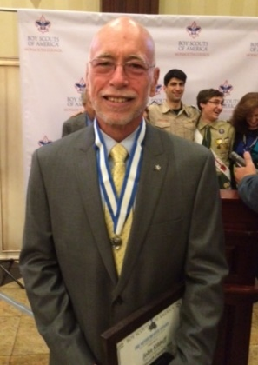**Chair’s Chat May, 2022**

**Calendar of Events (cont.) – Links included if available**

10/03/22 - Partial Merit Badge Completion Clinic (Aquatics), TBD

10/08/22 - 10/09/22 - [**Fall Wood Badge (Session 2 of 2)**](https://www.ncacbsa.org/wood-badge/), Camp Snyder, Haymarket, VA

10/11/22 - Commissioner's Meeting, 7:30pm (Virtual)

10/13/22 - Roundtable Meeting, 7:30pm, Zoom & Thoreau Middle School, Vienna, VA

10/15/22 - 10/16/22 - [**Jamboree on the Air/Jamboree on the Internet**](http://arrl.org/jamboree-on-the-air-jota)

10/17/22 & 10/22/22 - [**Leave No Trace Trainer course**](https://scoutingevent.com/082-49968), Germantown, MD

10/21-23/22 George Mason Fall Camporee – Theme & Site TBD

10/28-30/22 V3 HIKE-O-REE – see details on later pages

11/01/22 – 05/31/23 – Unit election season for Order of the Arrow begins

11/05/22 - Scouting for Food (Tag Distribution)

11/06/22 - [**Flags In Veterans Day**](https://www.ncacbsa.org/george-mason/district-resources/flags-in-veterans-day-2/), National Memorial Park, Falls Church, VA

11/12/22 - Scouting for Food (Food Pick-up)

11/08/22 - Commissioner's Meeting, 7:30pm (Virtual)

11/10/22 - Roundtable Meeting, 7:30pm, Zoom & Thoreau Middle School, Vienna, VA

11/30/22 – District Committee, 7:30pm, Zoom

12/08/22 - Roundtable Meeting, 7:30pm, Zoom & Thoreau Middle School, Vienna, VA

12/13/22 – Commissioner/District Committee Cracker Barrell, 7:30pm (Virtual)

02/25/23 - University of Scouting

04/28/22-04/30/23 – Patriot/George Mason OA Chapters Spring Ordeal Induction – Camp Snyder, Gainesville, VA

05/05/23 - 05/07/23 – George Mason Spring Camporee – Theme & Site TBD

05/29/23 – [**Flags In Memorial Day**](https://www.ncacbsa.org/george-mason/district-resources/flags-in/), National Memorial Park, Falls Church, VA

05/31/23 – Unit election season for Order of the Arrow closes

07/19/23 - 07/28/23 – [**BSA 2023 National Jamboree**](https://www.facebook.com/NatJamboree23/), The Summit Bechtel Reserve, WV,

Is it summer yet? School is out, Memorial Day is long behind, the Nats are more than 20 games back, still playing hockey?, Father’s Day is done, but the calendar says summer starts tomorrow. Good enough, let’s go! Off to vacations, picnics, summer camp, pool parties, high adventure, great weather, and all the things that make summer great. We have spent all year getting ready for this time. Let’s have fun!

We are wrapping up the season at the George Mason District as well. FOS wraps up this week and we are on the cusp of reaching our goal again this year. Thank you to all who helped make that possible. We have also finished the spring with 4% growth in membership. Great job! We will be taking a break in July from our monthly District Roundtable and District Committee meetings but will be back in August.

While summer gives us a chance to enjoy the fruits of our labors, it is also a time to reflect and plan for the Scouting year ahead. We just held the District “Program Launch” to help Packs and Troops get started with unit planning for activities and events in the next year. Program is essential to all we do to make Scouting work but don’t forget to make sure you attract new Cubs and Scouts by planning and advertising your various join Scouting events. Our council will again be paying to boost your events on Facebook so don’t forget to sign up for “Geofencing”. Boosted events attract a 20% larger audience.

Don’t forget about paying for all that program you are planning. The Trails End Popcorn sale will be starting just in time for your late summer and fall events and new Scouts. Please consider participating in the popcorn sale as either your main unit fundraiser or as an adjunct to whatever other fundraising you do. Consider having an online sale that doesn’t require handling any product or money.

Back to where we started. Have a great summer. Get recharged. Get “prepared”. I’ll see you on the trail.

John Kilduff – George Mason District Chair

732-610-4284 [johnkilduff42@gmail.com](mailto:johnkilduff42@gmail.com)

**George Mason District Executive Departs the District**

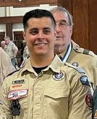After a year serving as George Mason District Executive, Jose Calil, has left professional Scouting. Jose is taking a career turn and will be working in the fitness industry as a gym manager in Springfield, VA. Jose served us well through a difficult time as we dealt with huge changes in technology, relationships with our charter organizations, bankruptcy, and coming back from remote meetings. Thank you, Jose. We wish you great success in your new career.

NCAC is actively seeking a new professional to assume our District Executive position. In the meantime, the Chain Bridge District Director will be providing us with professional support. Keenan Pallone can be reached at Keenan.Pallone@scouting.org.

**George Mason District Congratulates Brian Summers Sr.**

**Recipient of the 2022 NCAC Silver Beaver Award**

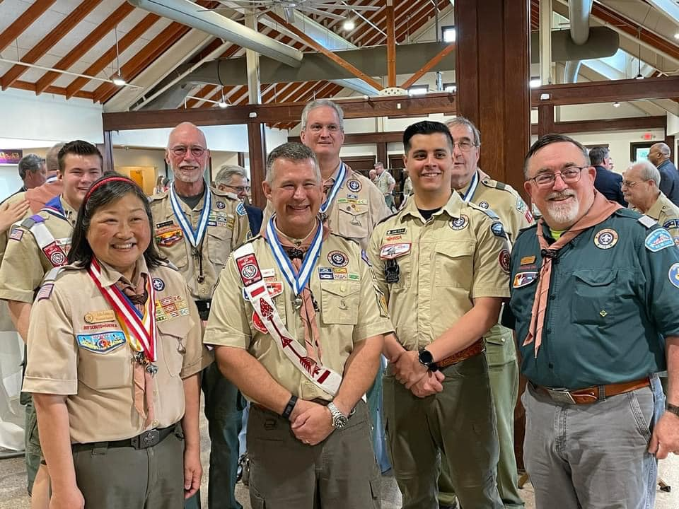May 22, 2022 at Camp Snyder

Brian Summers, SR is a scouter who professionally has spent over 30 years as an IT professional and is a Cyber Security Manager, PMP, and CISSP at ManTech international. Brian started his scouting career at age 11 in Troop 154 in Falls Church, VA. He earned the Youth Religious award, became a member of the Order of the Arrow, and became an Eagle Scout and lifelong membership in the National Eagle Scout Association.

He later enlisted in the US Army as a Combat Engineer. Brian returned to Scouting after starting his family, first as a Cub Master and then later an Assistant Scoutmaster with Troop 1978 in Vienna, VA. Brian has been recognized with the District Award of Merit and the Order of the Arrow Vigil Honor while supporting the George Mason District and the OA Chapter.

NCAC has recognized only 12 recipients of the Silver Beaver for 2022. Please congratulate Brian when you see him!

**2022 Journey to Excellence – NEW INFO from BSA**

[**https://www.scouting.org/awards/journey-to-excellence/**](https://www.scouting.org/awards/journey-to-excellence/)

Journey to Excellence is the Boy Scouts of America program to help Packs, Troops, Crews, Ships and Posts to plan, monitor and evaluate their performance and their ability to serve youth.   There are specific criteria for the unit to plan and accomplish. These standards are reviewed each year and revised standards are published.

The 2022 Journey to Excellence Standards are now available.

Here are the major changes in the JTE scorecards for 2022.

1. The standards are written as activities that the unit will do. This is to emphasize that JTE is primarily a planning tool.
2. The Cub Scout scorecard has many changed standards. This is because of changes in the Cub Scout program.
3. For standard #10, Gold now includes recruiting a new leader. We have found that the best units continually recruit parents and other adults who have never been involved in Scouting.

There is no requirement, no expectation and, in fact, we might discourage a unit from believing that they should achieve Gold in all JTE criteria.  A great unit is balanced in the service that it provides to youth. There is no shame and no problem if a unit achieves Silver or Bronze. That unit is serving youth. We regard the various colors as meaning:

Bronze – Effective  
Silver – Excellent  
Gold – Exceptional

Please share with us your thoughts about JTE and any suggestions that you have for improvement. Please sent them to [**jte@scouting.org**](mailto:jte@scouting.org)

National Assessment and Evaluation Committee  
Boy Scouts of America

[**2022 JTE Unit Scorecards**](https://www.scouting.org/awards/journey-to-excellence/unit/) **(PDF) links**

* [**Pack Scorecard**](https://www.scouting.org/wp-content/uploads/2022/04/2022-JTE-Pack-Spreadsheet-Cub-ScoutFinalR1.pdf)
* [**Troop Scorecard**](https://www.scouting.org/wp-content/uploads/2022/04/2022-JTE-Troop-Scorecard-FinalR3.pdf)
* [**Crew Scorecard**](https://www.scouting.org/wp-content/uploads/2022/04/2022-JTE-Crew-ScorecardR3.pdf)
* [**Ship Scorecard**](https://www.scouting.org/wp-content/uploads/2022/04/2022ShipJTEScorecardR1.pdf)
* [**Post Scorecard**](https://www.scouting.org/wp-content/uploads/2022/04/2022PostJTE.pdf)

**Izaak Walton League of America - IWLA Arlington Fairfax**

**2021 ARL-FX IWLA Education & Training Course Schedule**

Please direct all questions to the Chapter’s Director of Education & Training

John Seaberg @ [John.Seaberg@arlingtonfairfax-iwla.org](mailto:John.Seaberg@arlingtonfairfax-iwla.org).

|  |  |  |  |  |
| --- | --- | --- | --- | --- |
| **Date** | **Course** | **Cost** | **Registration** | **Payment** |
| July 23, 2022 | NRA Metallic Cartridge Reloading Course | $100 | [**Registration**](https://www.nrainstructors.org/CourseDetails.aspx?Courseid=696771&seats=16&State=n&zip=22032&radius=25.1&id=6&bsa=&youth=&women=) | [**Payapl**](https://www.paypal.com/cgi-bin/webscr?cmd=_s-xclick&hosted_button_id=W6SAD8FE5DXUG) |
| July 30, 2022 | NRA Basics of Shotgun Shooting Course | $75 | [**Registration**](https://www.nrainstructors.org/CourseDetails.aspx?Courseid=712984&seats=16&State=y&SearchState=VA&id=3&bsa=&youth=&women=) | [**Paypal**](https://www.paypal.com/cgi-bin/webscr?cmd=_s-xclick&hosted_button_id=5GG8RV4SGR7XY) |
| August 12-14, 2022 | NRA BIT and Basic CCW Instructor Course | $200 | [**Registration**](https://www.nrainstructors.org/CourseDetails.aspx?Courseid=701119&seats=20&State=y&SearchState=VA&id=77&bsa=&youth=&women=) | [**Paypal**](https://www.paypal.com/cgi-bin/webscr?cmd=_s-xclick&hosted_button_id=V5MR24ERMNCPS) |
| August 27, 2022 | NRA Basics of Pistol Shooting Course | $75 | [**Registration**](https://www.nrainstructors.org/CourseDetails.aspx?Courseid=706642&seats=20&State=n&zip=20124&radius=25.1&id=56&bsa=&youth=&women=) | [**Paypal**](https://www.paypal.com/cgi-bin/webscr?cmd=_s-xclick&hosted_button_id=K5EWFDYP4XML6) |
| September 18, 2022 | NRA Basic RSO Course | $100 | [**Registration**](https://www.nrainstructors.org/CourseDetails.aspx?Courseid=704261&seats=16&State=n&zip=20124&radius=25.1&id=5&bsa=&youth=&women=) | [**Paypal**](https://www.paypal.com/cgi-bin/webscr?cmd=_s-xclick&hosted_button_id=YG7DZ5UBZNSS2) |
| September 24-25, 2022 | NRA Basic CCW Course | $150 | [**Registration**](https://nrainstructors.org/CourseDetails.aspx?Courseid=696256&seats=20&State=n&zip=20120&radius=25.1&id=76&bsa=&youth=&women=) | [**Paypal**](https://www.paypal.com/cgi-bin/webscr?cmd=_s-xclick&hosted_button_id=MXLU7U4SZ3YQ4) |
| October 8-9, 2022 | NRA Level 1 Shotgun Coach School | $225 | [**Registration**](https://www.nrainstructors.org/CourseDetails.aspx?Courseid=698522&seats=16&State=n&zip=20124&radius=25.1&id=46&bsa=&youth=&women=) | [**Paypal**](https://www.paypal.com/cgi-bin/webscr?cmd=_s-xclick&hosted_button_id=FBFY9XPPY48JL) |
| October 22, 2022 | NRA Basics of Shotgun Shooting Course | $75 | [**Registration**](https://www.nrainstructors.org/CourseDetails.aspx?Courseid=713036&seats=16&State=y&SearchState=VA&id=3&bsa=&youth=&women=) | [**Paypal**](https://www.paypal.com/cgi-bin/webscr?cmd=_s-xclick&hosted_button_id=ETW48BQ9AG2VS) |
| November 12-13, 2022 | NRA Level 1 Rifle Coach School | $225 | [**Registration**](https://www.nrainstructors.org/CourseDetails.aspx?Courseid=696775&seats=20&State=n&zip=22032&radius=25.1&id=44&bsa=&youth=&women=) | [**Paypal**](https://www.paypal.com/cgi-bin/webscr?cmd=_s-xclick&hosted_button_id=BT2A27E6N4VVS) |
| November 19, 2022 | Shotgun Shell Reloading Course | $100 | [**Registration**](https://www.nrainstructors.org/CourseDetails.aspx?Courseid=699514&seats=16&State=y&SearchState=VA&id=10&bsa=&youth=&women=) | [**Paypal**](https://www.paypal.com/cgi-bin/webscr?cmd=_s-xclick&hosted_button_id=MC7VWTYP774ME) |
| December 4, 2022 | NRA Basic RSO Course | $100 | [**Registration**](https://www.nrainstructors.org/CourseDetails.aspx?Courseid=706616&seats=20&State=n&zip=20124&radius=25.1&id=5&bsa=&youth=&women=) | [**Paypal**](https://www.paypal.com/cgi-bin/webscr?cmd=_s-xclick&hosted_button_id=DEA8M6XX46UEG) |

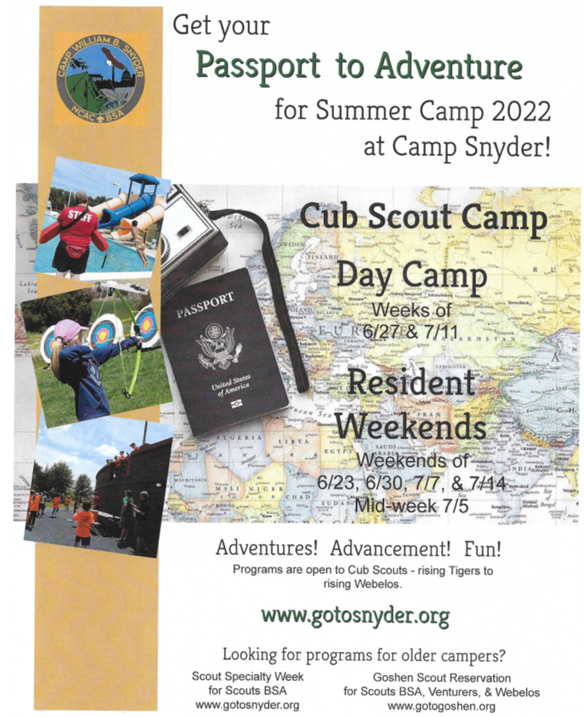

[**WWW.gotosnyder.org**](http://WWW.gotosnyder.org)

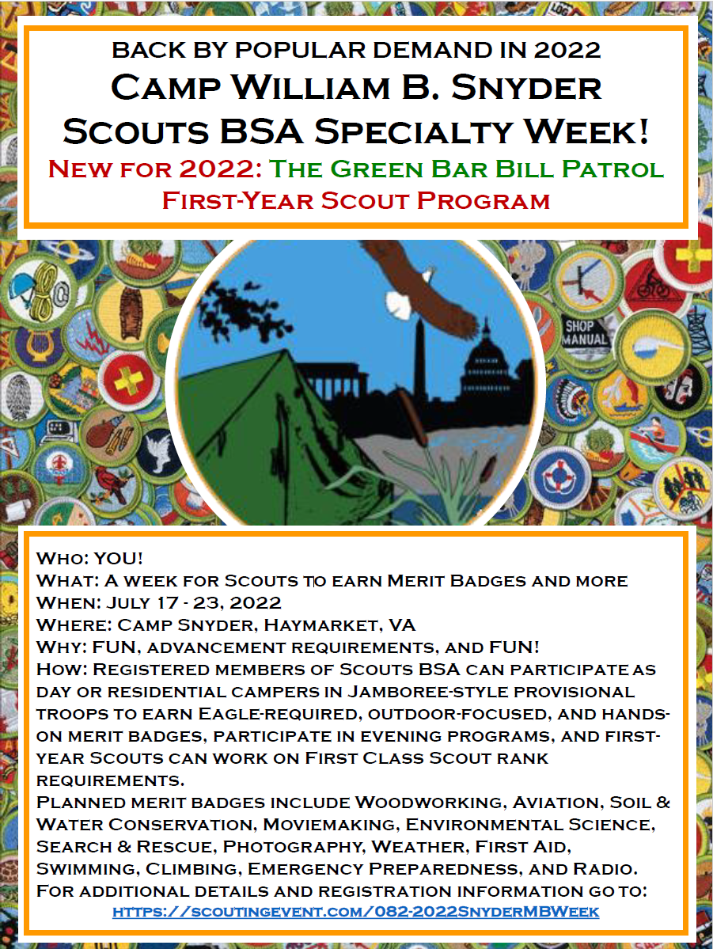<https://scoutingevent.com/082-2022SnyderMBWeek>

**Camp Snyder Sawdust Saturdays**

For Camp Snyder Sawdust Saturdays on scheduled dates (see the calendar below), **please contact Dan Kurtenbach to let us know you are coming**.  Use the [sign up link](https://nam12.safelinks.protection.outlook.com/?url=https%3A%2F%2Fdocs.google.com%2Fforms%2Fd%2F1rlc0T_1GCGfA1Y8YjypzmuR4dooy7VBWSSOLuV2NXio%2Fedit&data=04%7C01%7C%7C47968027a5ab41d24bc408da07715b7d%7C84df9e7fe9f640afb435aaaaaaaaaaaa%7C1%7C0%7C637830480854691128%7CUnknown%7CTWFpbGZsb3d8eyJWIjoiMC4wLjAwMDAiLCJQIjoiV2luMzIiLCJBTiI6Ik1haWwiLCJXVCI6Mn0%3D%7C3000&sdata=b6SQyDZh8pFFS32haGqQuS0cnO7BwpvE9oWXWgTGit8%3D&reserved=0) on our Camp Snyder volunteer project [webpage](https://nam12.safelinks.protection.outlook.com/?url=https%3A%2F%2Fwww.gotosnyder.org%2Fwork-volunteer%2Fservice-days%2F&data=04%7C01%7C%7C47968027a5ab41d24bc408da07715b7d%7C84df9e7fe9f640afb435aaaaaaaaaaaa%7C1%7C0%7C637830480854691128%7CUnknown%7CTWFpbGZsb3d8eyJWIjoiMC4wLjAwMDAiLCJQIjoiV2luMzIiLCJBTiI6Ik1haWwiLCJXVCI6Mn0%3D%7C3000&sdata=ydxtUQRm3RXMbGLsVhhEYT2iUTHkSLWe%2BOyB1Fs%2FQYs%3D&reserved=0), call Dan at 703-802-0613, or email him at [cwbs.volunteers@gmail.com](mailto:cwbs.volunteers@gmail.com).  Please review the COVID-19 precautions in the box below.

**Individual “Come When You Can” Service**

For individual service opportunities at Camp Snyder on your own schedule, contact Camp Ranger Ryan Alford, 615-934-7962 (mobile), [ryan.alford@scouting.org](mailto:ryan.alford@scouting.org), to discuss a date, time, and available projects.

* ARRIVAL WINDOW:  9:00 AM to 11:00 AM.  Come any time during the arrival window and someone will be there.  We usually finish by mid-afternoon.  If you’d like to come earlier or later, please call or text before you leave home to see if someone will be at camp**.  Call or text Dan Kurtenbach at 703-802-0613 or Ryan Alford at 615-934-7962.**
* FIND US:  When you arrive at camp, **call or text Dan Kurtenbach at 703-802-0613 or Ryan Alford at 615-934-7962**.  If you are not familiar with Camp Snyder, use the map below (also attached).
* BRING:  Drinking water, personal hand sanitizer, disinfectant wipes, and/or other personal cleaning supplies.
* WEAR:  Outerwear, sun protection, and insect protection appropriate for the season and weather.
* WEAR:  Work clothes that can get dirty, torn, or permanently stained.
* WEAR:  Closed-toe shoes or boots, work gloves, eye protection, and ear protection (when using loud equipment).
* BRING:  Tools you like to use if you have them.  Tools that get a lot of use are:  battery-powered drills/drivers with bits for Phillips #2 and Star T-25 screws; hammers; pry bars; and – you guessed it – saws.

**2022 Sawdust Saturdays Schedule:**

July – Off

August 20, 2022

September 17, 2022

October 15, 2022

November 12, 2022

December 17, 2022

**NCAC Aquatics Committee - Program 2022**

[**https://www.ncacbsa.org/aquatics-committee/**](https://www.ncacbsa.org/aquatics-committee/)

The NCAC Aquatics Committee is please to confirm the following programs.

**Paddle Craft Safety** – Fall = Limit 16 Scouts/Leaders  
 Course Fee $30/day  
 Still water course includes ***Canoe Merit Badge Counselor Certification***  
 Still water required for Moving Water  
 September 10, 2022 @8:00am – Still Water Safety – Silver Lake  
 Class at the Hylton Center – am  
 Silver Lake - pm  
 September 11, 2022 @8:30am – Moving Water Safety – Potomac River  
 Rileys Lock – On the Potomac

**James River Adventure Crew**  
 July 17 – 23, 2022 – Sign-up on High Adventure Committee site  
 [**https://www.gotogoshen.org/camps-programs/lenhoksin-high-adventure/**](https://gcc02.safelinks.protection.outlook.com/?url=https%3A%2F%2Fwww.gotogoshen.org%2Fcamps-programs%2Flenhoksin-high-adventure%2F&data=04%7C01%7Ccharles.hochstein%40usps.gov%7C0f5f2b6ce5f44ec7d7d208d9da18b712%7Cf9aa5788eb334a498ad076101910cac3%7C0%7C0%7C637780621958630929%7CUnknown%7CTWFpbGZsb3d8eyJWIjoiMC4wLjAwMDAiLCJQIjoiV2luMzIiLCJBTiI6Ik1haWwiLCJXVCI6Mn0%3D%7C3000&sdata=6k5Qj8sH9y%2B9Eb4WhkEksa9mD08G7uG8YfObrXKHuBs%3D&reserved=0)

**SCUBA – PADI Certification** by Age / Scouts BSA Merit Badge  
 PADI Divemaster Andrew Blanco (Email [**ABSEAS2@aol.com**](mailto:ABSEAS2@aol.com) to schedule)  
 Fee $650 - Minimum age 14 years   
 Three Sessions:

* [**July 9-10 Pool Session & July 16-17 – Open Water**](https://scoutingevent.com/082-60040)
* [**Aug 6 & 7 – Pool Session & Aug 13 & 14 – Open Water**](https://scoutingevent.com/082-60034)
* [**Aug 20 &21 – Pool Session & Aug 27 & 28 – Open Water**](https://scoutingevent.com/082-60034)

**Partial Merit Badge Completion Clinic**  
 Tentative -TBD - October 3, 2022 - 18 Scout Limit

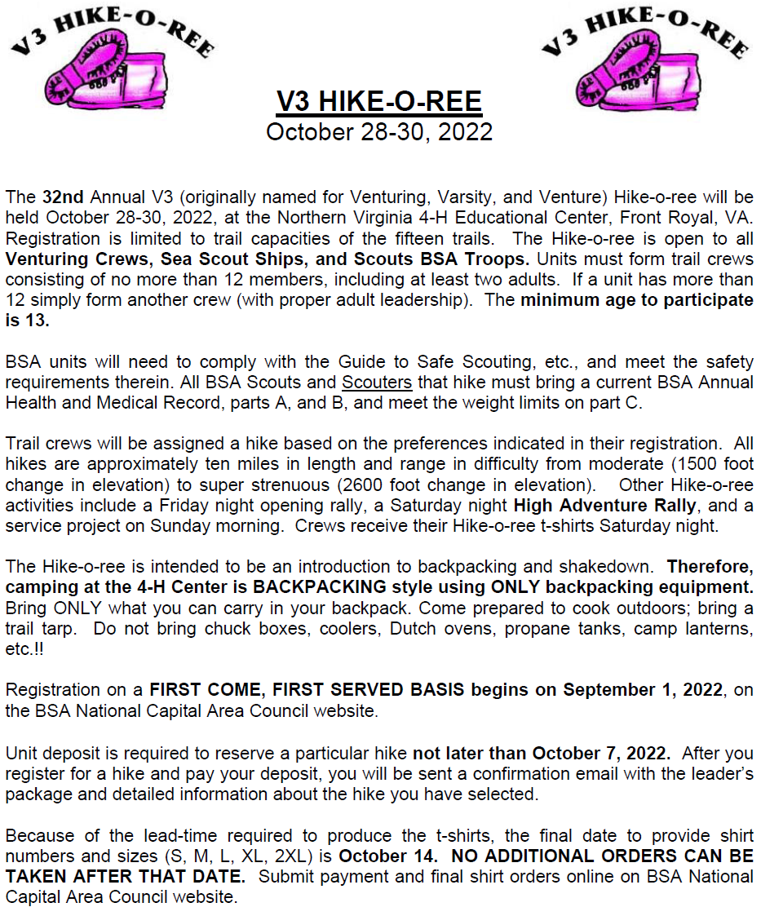

**For additional information contact:**

Joe Flaig, (703) 250-9791 (H), [jwflaig@aol.com](mailto:jwflaig@aol.com)

Terry Gigure, [awpm2k@cox.net](mailto:awpm2k@cox.net)

Dominick Caridi, (703) 625-4196, [dscscouting@aol.com](mailto:dscscouting@aol.com)

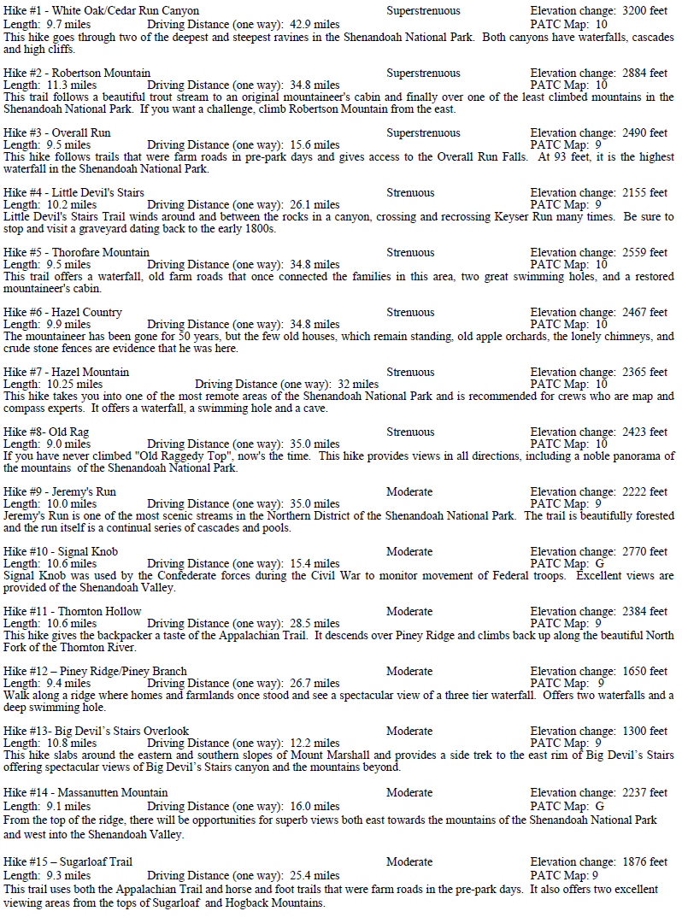

**Leave No Trace Trainer Course – Outdoor Ethics**

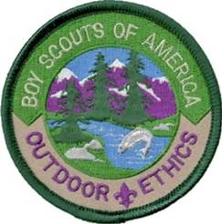

**Purpose of this Course**

Participants in the Trainer Course learn Leave No Trace skills and ethics as well as techniques for educating others about these low impact practices. Research has shown that this course significantly improves participant knowledge and understanding of how Leave No Trace protects the outdoor places we love. The goal of this course is to teach students taking the course how to introduce the concept of Outdoor Ethics in a fun and engaging way to a group with little experience in outdoor ethics. It should help youth and adults at all program levels understand the general principles behind Scouting's outdoor ethics program. Graduates of a Trainer Course are prepared to lead Outdoor Ethics Orientation and BSA Leave No Trace 101 courses and to offer Leave No Trace Awareness Workshops to their community.

We recommend that youth complete this course before serving as in the troop Outdoor Ethics Guide position.

**Who should attend?**

This course will be of interest to any youth or registered Scouter who is associated with either implementing or training for any BSA outdoor program at any level. It is also well-suited for anyone who would like to pass on the knowledge of how to treat the outdoors and protect its beauty for others to enjoy. Youth must be at least 14 years old. Youth must be willing and able to conduct themselves appropriately for an adult training experience that is tightly scheduled and highly interactive.

We're pleased to offer 3 LNT Trainer courses in 2022 in NCAC. Please share widely with your units, scouts, scouters, families, and NCAC networks. Thanks much!

**October 2022 course in Virginia:**10/17/2022, 7pm-8pm online  
10/22/2022, 9am-7pm @ Haymarket VA  
[https://scoutingevent.com/082-55114](https://scoutingevent.com/082-49968)

**Sept/Oct 2022 course in Maryland:**9/26/2022, 7pm-8pm online  
10/1/2022, 9am-7pm @ Germantown MD  
<https://scoutingevent.com/082-55113>

++++++++++++++++++++++++++++++++++++++++++++++++++++++++++++++++++++++++++++++++++++++++++++++++++

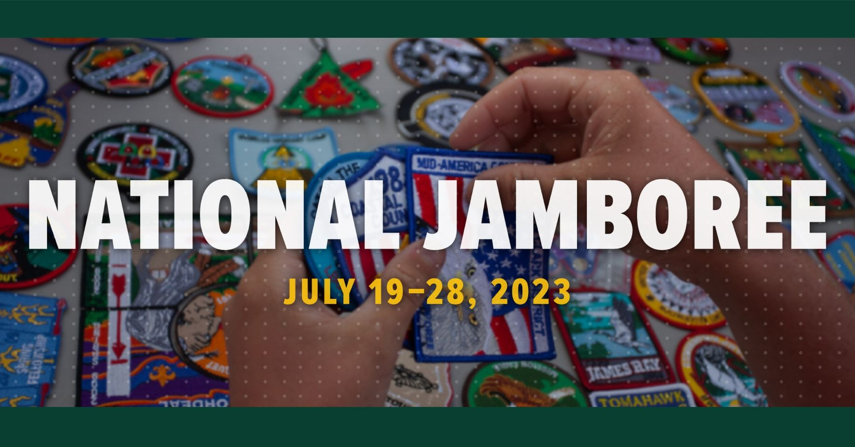

**Welcome to the official page of the Boy Scouts of America's 2023 National Jamboree. July 19-28, 2023, at The Summit Bechtel Reserve in West Virginia:**

<https://www.facebook.com/NatJamboree23/>

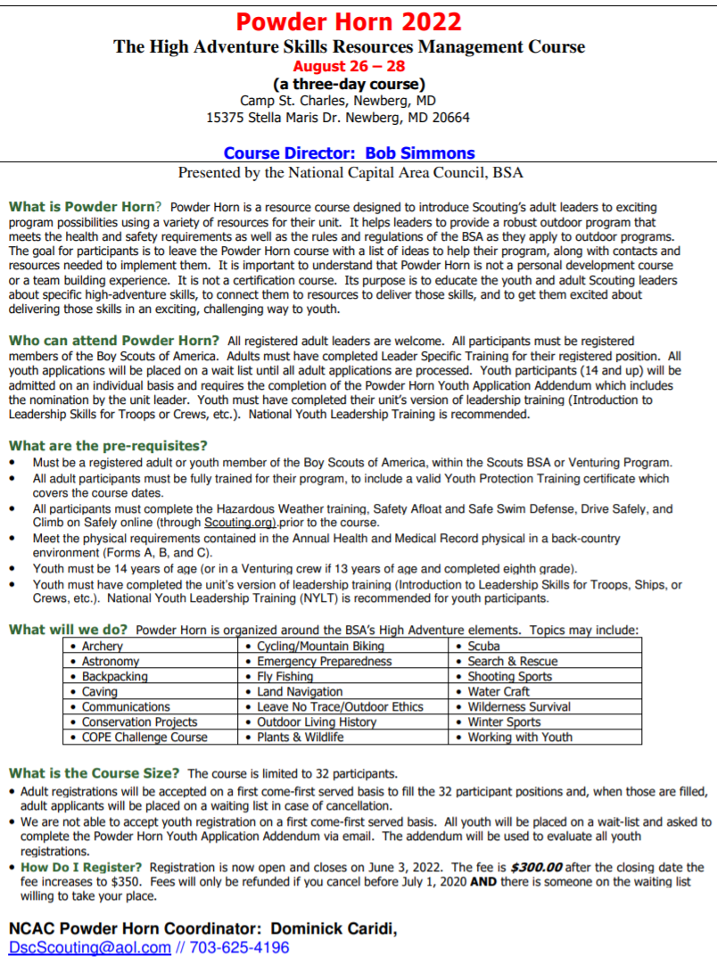

**Wood Badge - Registration:** <https://scoutingevent.com/082-49317>

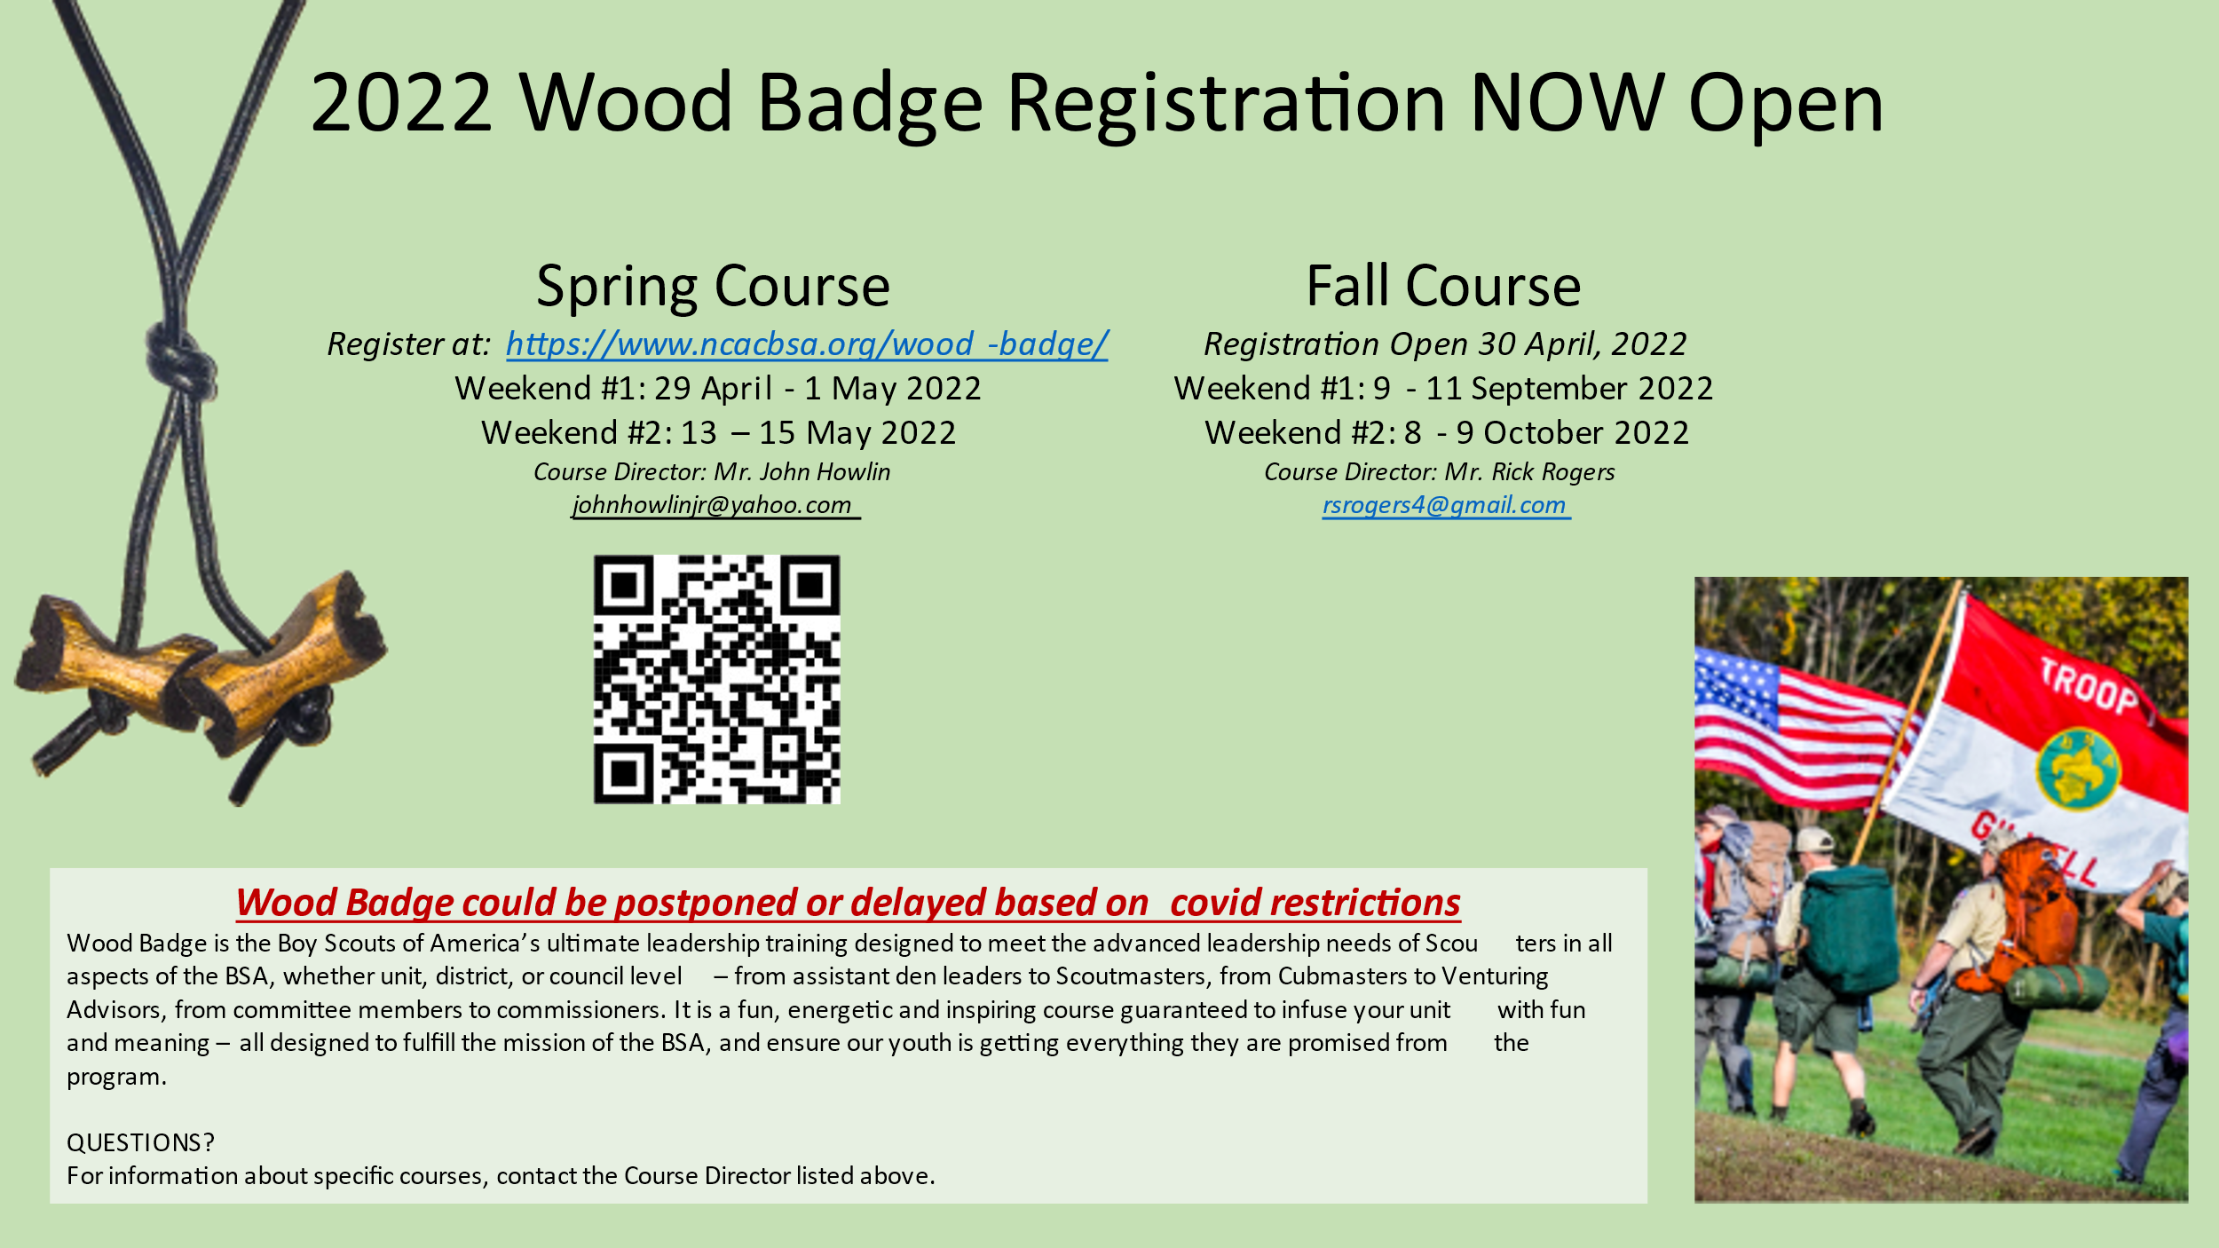

Wood Badge is an advanced, national leadership course open only to Scouting volunteers and professionals. Scouters from Cub Scouting, Scouts BSA, Venturing, Sea Scouts, and Explorers, and district and council Scouters all are welcome and belong here.

**Listen to the**[**April 2017 CubCast,**](https://podcast.scouting.org/cubcast/2017/april-2017-tell-us-more-about-wood-badge/)**“Tell Us More About Wood Badge,” to learn more about this advanced leadership training course.**

## **What do we see on course?** We do many things on course, like:

* Listening
* Managing conflict
* Leading change
* Stages of team development
* Coaching & Mentoring
* Leadership for different stages
* Servant leadership
* Project planning
* And more!

These come to you in presentations, games, discussions, activities, and other methods.

## **Wood Badge (cont.)**

## **Why do you want to go?**

You want to participate in a Wood Badge course because of things you will learn and do. Here are some of the benefits:

* **Stronger units.** You will make your Scouting unit — and your sons’ and daughters’ units — stronger.
* **What and why of Scouting.** You will have a deeper understanding of what Scouting is and why we do it.
* **Experience.** You will learn and experience things that will stay with you in Scouting and the rest of your life.
* **Fun.** You will have fun and you will meet interesting people.
* **Other groups.** You will make your other groups, like work, church, even family, stronger.

Here’s another summary of why to go. This was originally aimed particularly at Scouters in the Cub Scout program, but it applies equally to all of us.

CUB SCOUT LEADERS! How would you like to attend a training that takes you far beyond your Basic Leader Training? Would you like to build your skills in communication, conflict management and teaching methods? How about a leadership course that rivals many corporate level trainings?

Wood Badge is here for you. This is not a Troop leader training but is designed for Cub, Scout, and Venturing leaders. This course will help you better understand how all the Scouting programs tie together. It will provide you with many useful leadership tools to help enable our youth to have the best possible Scouting experience. There is no better time to attend a Wood Badge course and make a difference in your unit than when you are a Cub Scout Leader.

## **Tickets**

Have you heard of “The Ticket” and wondered what it is? The ticket is a group of five goals you set for yourself to do after course, to improve your unit. You learn more about this on the course.

## **Purpose of Wood Badge**

***The purpose of Wood Badge is to develop skilled leaders who can strengthen Scouting units in achieving the mission of the Boy Scouts of America.***

When we accomplish the mission of Scouting, we do it in the units. Therefore, the short form of the purpose is, the purpose of Wood Badge is to strengthen units.

Although the course is different today, what Baden-Powell said in 1919 still applies:

One of the purposes of Wood Badge training is to get Scouters to think about the practice of Scouting, to meet together, to exchange experiences, and to live together in the spirit of the Scout Oath.



|  |
| --- |
| ***BE PREPARED...*** ***NCAC NYLT Summer Registration Is Open!!*** at [https://www.ncacbsa.org/national-youth-leadership-training/](https://gmail.us3.list-manage.com/track/click?u=4454ab63512dcc3c357428184&id=6e85aebeec&e=a7c4835fcf) |

**2022 Course Schedule**

**22-4: July 24-29 @ Camp Snyder, VA*  
22-5: July 24-29 @ Camp Snyder, VA\***

**\* Courses running concurrently**

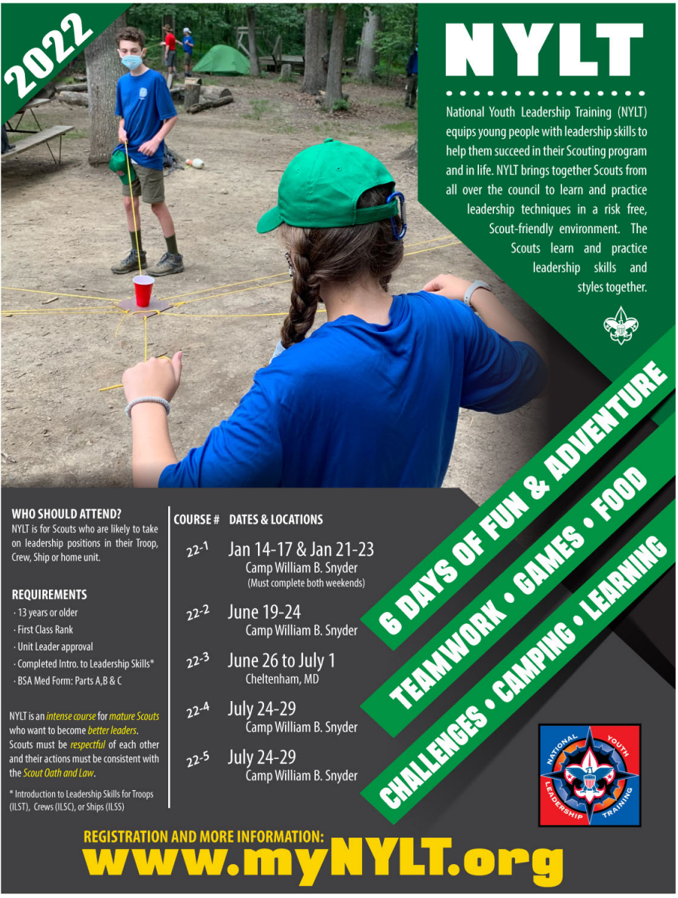[Download Flyer PDF (363kb)](https://gmail.us3.list-manage.com/track/click?u=4454ab63512dcc3c357428184&id=d8c2aa956b&e=a7c4835fcf)

***Merit Badge Program***

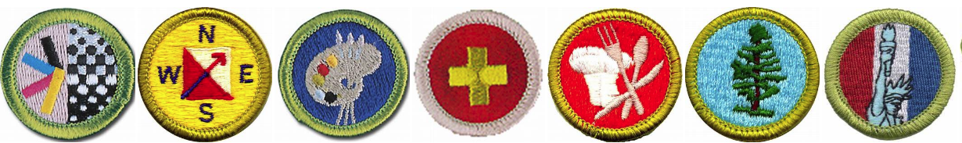

The Scouting BSA is a movement dedicated to supplementing and enlarging the education of youth. As a vital part of the BSA’s advancement plan, the merit badge program is one of Scouting’s basic character-building tools and plays a key role in the fulfillment of this educational commitment. There are over 100 different merit badges in the program. Upcoming events will be listed below:

* [**Online Merit Badge Courses**](https://www.hoac-bsa.org/scoutconnect) - Watch video, fill out workbook, contact Counselor
* [**Parktakes**](https://fairfax.usedirect.com/fairfaxfcpaweb/Activities/Search.aspx)(select "Scouts" from the Category of Activity)
* [**MeritBadge.Info**](http://meritbadge.info/) - Various MB Days throughout the country
* [**Fly Fishing Merit Badge Program**](http://www.ncacbsa.org/wp-content/uploads/2017/02/BSA-Flier.pdf), Northern Virginia
* [**Merit Badges Scouts can complete at Home**](https://blog.scoutingmagazine.org/2020/03/20/merit-badges-for-social-distancing/)

**Current Merit Badge Counselors and Guidelines:**

***The current roster of merit badge counselors is provided periodically to the Scoutmaster of each troop.*** If a scout needs information about a specific merit badge, the scout can contact their troop leadership or the George Mason Merit Badge Dean **(note emails should include two adults - no one-on-one contact for electronic media).**

**To become a Merit Badge Counselor:**

You can apply online [**here**](https://my.scouting.org/VES/OnlineReg/1.0.0/?tu=UF-MB-082gm23)(note, please ensure you have a current YPT before filling out application).  When you are done with the application, send the MB Dean your list of MBs using the [**Merit Badge Counselor Information Sheet**](https://filestore.scouting.org/filestore/pdf/34405.pdf).

Any questions or concerns please contact the District's Merit Badge Dean:

Margee Egan at [**margee.egan@gmail.com**](mailto:gm.mb.dean@hotmail.com)

**TROOP UNIT LEADERS including COMMITTEE CHAIRMEN**

As you prepare for your Unit’s upcoming 2022-2023 program, we wanted to remind you of the requirements needed for a youth or adult to become an Order of the Arrow Ordeal **Candidate**.

**Youth Membership Qualifications**:

1. Be a **registered member of the Boy Scouts of America**.

2**. At the time of their election, youth must be under the age of 21**, **hold the Scouts BSA First Class rank, the Venturing Discovery Award, or the Sea Scout Ordinary rank or higher**, and following **approval by the scoutmaster**, crew advisor or Sea Scout skipper**, be elected by the youth members of their unit**.

3. The youth must have experienced **15 nights of camping** while registered with a troop, crew or ship within the two years immediately prior to the election. The 15 nights must include **one, but no more than one, long-term camp** consisting of at least five consecutive nights of overnight camping, approved and under the auspices and standards of the Boy Scouts of America. **Only five nights of the long-term camp may be credited toward the 15-night camping requirement**; the balance of the camping (10 nights) must be overnight, weekend, or other short-term camps of, at most, three nights each. Ship nights may be counted as camping for Sea Scouts.

4. Assistant scoutmasters who are 18, 19 or 20 years old are also considered to be youth members for the purpose of OA elections. All requirements shown above must be met for a young assistant scoutmaster to be eligible for election.

Prior to the annual election, the unit leader must certify the nominee’s Scout spirit and youth membership qualifications. Voting for youth candidates will be based on their spirit of brotherhood, cheerfulness (no matter how tiresome their duties), and a willingness to give unselfish and wholehearted service to others at all times.

**Adult Membership Qualifications**:

Each year, upon holding a unit election for youth candidates that results in at least one youth candidate being elected, the unit committee may nominate registered unit adults, 21 years of age or older, to the lodge adult selection committee. The number of adults nominated can be no more than one-third of the number of youth candidates elected, rounded up where the number of youth candidates is not a multiple of three. In addition to the one-third limit, the unit committee may nominate the currently serving unit leader (but not assistant leaders), as long as he or she has served as unit leader for at least the previous 12 months. Recommendations of the adult selection committee, with the approval of the Scout executive, will be candidates for induction, provided the following conditions are fulfilled:

1**. Selection of the adult is based on the ability to perform the necessary functions to help the Order fulfill its purpose and is not for recognition of service, including current and prior achievements and positions.**

2**. The individual will be an asset to the Order because of demonstrated abilities that fulfill the purpose of the Order.**

3. The **camping requirements set forth for youth members are fulfilled.**

4. The adult leader’s membership will provide a positive example for the growth and development of the youth members of the lodge.

**George Mason Chapter Order of the Arrow (OA)**

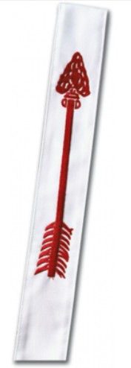

The George Mason Chapter of the O/A is back to meeting in Person on the 2nd Thursday of the month at Thoreau Middle School from 7:30-8:30. (Same time/location as GM Roundtable.)

9/30-10/02/2022 – Patriot/George Mason Chapters Fall Area Ordeal Induction – Camp Snyder, Gainesville, VA

11/01/2022 – 05/31/2023 – Unit election season for Order of the Arrow

4/28-30/2023 – Patriot/George Mason Chapters Spring Ordeal Induction – Camp Snyder, Gainesville, VA

**Amangamek-Wipit Lodge - Annual Dues**

To attend any OA event or wear your sash and lodge flap, you must be a current dues-paying member of our lodge!  For 2022, annual dues will be $14 until March 31, 2022, when they increase to $16 on April 1, 2022 (no fooling!).  Payment may be made by credit card or e-check.

You will have an opportunity to make a contribution to help support our lodge activities and operations.  Become a Lodge Contributor by making a $100 contribution and receive our special Lodge Contributor patch and the satisfaction of knowing that you've dramatically helped further our mission of brotherhood, cheerfulness, and service.

If you are transferring from another lodge, please visit the Membership Dues and Transfers page on the lodge website <https://scoutingevent.com/082-MembershipTransfer> and complete the [Membership Transfer Form](https://www.ncacbsa.org/wp-content/uploads/2015/12/Membership-Transfer-Form.pdf) to pay your dues.

[Pay OA Dues](https://scoutingevent.com/082-52773)

**2022** Amangamek-Wipit Lodge Calendar

|  |  |  |  |  |
| --- | --- | --- | --- | --- |
| **Date** | **Time** | **Name** | **Location** | **Group Responsible** |
| JAN |  |  |  |  |
| Postponed Until Spring Fellowship |  | 2022 Lodge Banquet | (April 1-3, 2022) | Banquet Committee |
| 22 |  | ACT Conference | Central Pres. Ch., Towson, MD | Section Leadership |
| FEB |  |  |  |  |
| 13 | 3-5 pm | LEC | MSSC (plus virtual) | Lodge Leadership |
| 26 |  | University of Scouting | Hayfield School, Alexandria, VA | Training Committee |
| MAR |  |  |  |  |
| 6 | 3-5 pm | LO&A | Virtual | Key 7 |
| Pending Fianaliation |  | Camping-palooza | Camp Snyder, Haymarket, VA | Camping-palooza Committee |
| APR |  |  |  |  |
| 1-3 |  | 2022 Spring Fellowship | Camp Snyder, Haymarket, VA | Spring Fellowship Committee |
| 2 |  | RAMADAN begins |  |  |
| 3 | 12-2 pm | LEC (@ Fellowship) | Camp Snyder, Haymarket, VA | Lodge Leadership |
| 15 |  | PASSOVER begins |  |  |
| 17 |  | EASTER |  |  |
| 23 |  | PASSOVER ends |  |  |
| MAY |  |  |  |  |
| 1 | 3-5 pm | LO&A | Virtual | Key 7 |
| 2 |  | RAMADAN ends |  |  |
| 20-22 |  | Section Conclave | Broad Creek SR, Whiteford, MD | Section Leadership |
| 31 |  | Unit Election Season Closes |  |  |
| JUN |  |  |  |  |
| 11 |  | LLDC | TBD | Training Committee |
| 11 | 3-5 pm | LEC (After LLDC) | Same as LLDC | Lodge Leadership |
| 18 |  | Goshen Staff First Day | Goshen Scout Reservation, VA | GSR Director |
| 26 |  | GOAT Begins | Goshen Scout Reservation, VA | GOAT Committee |
| 26 | 8-11 am | Goshen Bus Loading -Day 1 | Fairfax County Gov. Center, VA | GBL Committee |
| JUL |  |  |  |  |
| 2 | 8-11 am | Goshen Bus Loading -Day 2 | Fairfax County Gov. Center, VA | GBL Committee |
| 3 | 8-11 am | Goshen Bus Loading -Day 3 | Fairfax County Gov. Center, VA | GBL Committee |
| 9 |  | GOAT Ends | Goshen Scout Reservation, VA | GOAT Committee |
| 9 | 8-11 am | Goshen Bus Loading -Day 4 | Fairfax County Gov. Center, VA | GBL Committee |
| 10 | 8-11 am | Goshen Bus Loading -Day 5 | Fairfax County Gov. Center, VA | GBL Committee |
| 16 | 8-11 am | Goshen Bus Loading -Day 6 | Fairfax County Gov. Center, VA | GBL Committee |
| 17 | 8-11 am | Goshen Bus Loading -Day 7 | Fairfax County Gov. Center, VA | GBL Committee |
| 23 | 8-11 am | Goshen Bus Loading-Day 8 | Fairfax County Gov. Center, VA | GBL Committee |
| 24 | 8-11 am | Goshen Bus Loading -Day 9 | Fairfax County Gov. Center, VA | GBL Committee |
| 25-30 |  | NOAC | University of Tenn., Knoxville | NOAC Committee |
| 30 | 8-11 am | Goshen Bus Loading -Day 10 | Fairfax County Gov. Center, VA | GBL Committee |
| AUG |  |  |  |  |
| 2 |  | Goshen Staff Last Days | Goshen Scout Reservation, VA | GSR Director |
| 5-7 |  | 2022 Vigil Induction (1st) | Goshen Scout Reservation, VA | Vigil Induction Committee |
| TBD |  | Lodge Summer Ordeal | Camp Snyder, Haymarket, VA | Lodge Ordeal Committee |
| 21 | 3-5 pm | LEC | MSSC (plus virtual) | Lodge Leadership |
| SEP |  |  |  |  |
| 5 |  | LABOR DAY |  |  |
| 16-18 |  | 2022 Fall Fellowship | Camp Snyder, VA | Fall Fellowship Committee |
| 18 | 12-2 pm | LO&A (@ Fellowship) | Camp Snyder, VA | Key 7 |
| 25-27 |  | ROSH HASHANAH |  |  |
| OCT |  |  |  |  |
| 2 | 3-5 pm | LEC | MSSC (plus virtual) | Lodge Leadership |
| 4-5 |  | YOM KIPPPUR |  |  |
| NOV |  |  |  |  |
| 1 |  | Unit Election Season Opens |  |  |
| 6 | 3-5 pm | LO&A | MSSC | Key 7 |
| 25-26 |  | 2022 Vigil Induction (2nd) | Camp Snyder, Haymarket, VA | Vigil Induction Committee |
| DEC |  |  |  |  |
| 4 | 3-5 pm | LEC | MSSC (plus virtual) | Lodge Leadership |
| 2-3 |  | 2022 Trade-O-Ree | Camp Snyder, Haymarket, VA | Trade-O-Ree Committee |

|  |  |
| --- | --- |
|  | To be determined by others |
|  | To be determined by us, the Lodge |

**Lodge Website:** [**Wipit470.org**](http://www.wipit470.org/)

9/30-10/02/2022 – Patriot/George Mason Chapters Fall Area Ordeal Induction – Camp Snyder, Gainesville, VA

4/28-30/2023 – Patriot/George Mason Chapters Spring Ordeal Induction – Camp Snyder, Gainesville, VA