 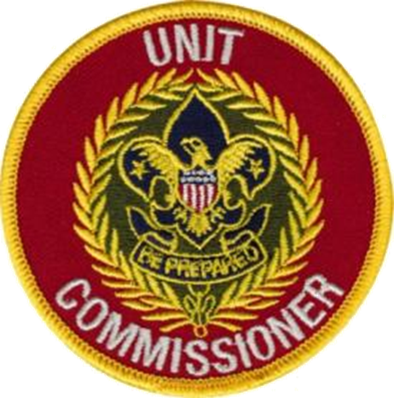

***Email Pre-registration requested by Tuesday, November 6th [Send to Registrar, below]***

***Name_______________________________________________ Home Phone # (____)***

***___________________________ Cell # (______)____________________________***

***E-mail: _______________________________________________________________________***

***Home address: __________________________________City_______________State_____Zip_______  
   
Registered Position _____________________BSA id#_____________***

***District___________________***

**Who: Unit Commissioners** **and those interested in Commissioner Service**

**What:** UCBT is the entry-level course for unit commissioners. Topics include: why commissioners, the commissioner service role, supporting units, unit program planning, commissioner priorities, counseling, JTE, Commissioner Tools, the unit service plan, conducting and reporting unit assessments, the commissioner’s role in saving units from disbanding, and using the District Committee to help commissioners maintain solid units. Unit Commissioner onboarding will also be addressed.

**When: Saturday,** November 10, 2018Registration 8:30 to 9:00AM, Training 9:00AM to 3:00 PM

**Where:** Our Lady of Good Counsel Catholic Church, 8601 Wolftrap Rd Vienna VA 22182. Class is in

LOWER LEVEL of DeSales Hall, in Music Room. DeSales Hall is on the left side of the main

Church entrance. Entrance to LOWER LEVEL is off small parking lot on left side of building.

Enter Parking lot off Niblick (lower lot) or off Wolftrap (upper lot). Craft Fair going in Upper Level

of DeSales Hall.

**Other:** - Refreshments will be available. Please ***bring a bag lunch and beverage.***

UCBT is also available online at the BSA Learn Center under my.scouting.org

**Questions? Contact: Pat Berney, George Mason DC**

Home 703-255-2445, Cell 703-896-0938

E-mail: patberney4scouts@gmail.com (preferred)



**UNIT COMMISSIONER BASIC TRAINING**