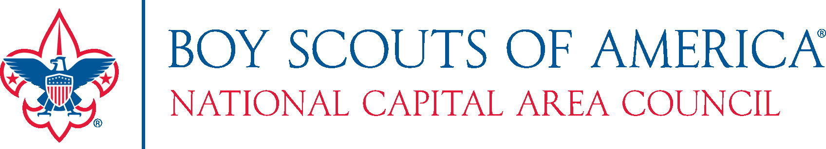
Greetings <INSERT NAME>:
The information listed below is to assist the person responsible for completing the charter renewal process for your unit.
Additional information is also available at your Council’s Roundtable and on the National Capital Area’s website www.ncacbsa.org/
To access the Unit Charter Renewal System (UCRS)
Go to: www.ncacbsa.org/commissioners/unit-rechartering/
Required documents to turn in to the council in order to finalize the process:
- All pages of the Unit Charter Renewal Report Package (no draft copies please).
- BSA Adult or Youth applications for everyone listed as “new” on page one of the Charter Renewal Report Package. Adult applications MUST include a signed Disclosure/Authorization form.
- Youth Protection Training Certificates - YPT is available online at http://my.scouting.org.
- One check -- made payable to Boy Scouts of America.
PLEASE NOTE:
- The final paperwork must include appropriate signatures on all individual adult and youth applications and on the Charter Renewal Application. The lack of appropriate signatures may delay processing of your charter renewal.
- Youth Protection Training is required for all adult leaders and must be completed every two years. Please confirm that every adult leader has current YPT before turning in the final renewal paperwork.
Other documents strongly encouraged to be turned-in:
Journey to Excellence Form: JTE forms are available online at: http://www.scouting.org/scoutsource/Awards/JourneyToExcellence/scorecards/2016.aspx.
Additional useful forms (Membership Inventory, Unit Budget Plan, New Youth & Adult Applications, etc.) may be found on scouting.org:
http://www.scouting.org/sitecore/content/Home/Membership/Registration.aspx and can be printed and used to assist in the completion of your unit’s 2018 charter renewal.
______________________________________________________________________________
*** UNIT ACCESS CODE ***
District: <District Name and Number>
Access Code: <XXXXXXXXX>
Charter Organization: <Sponsoring Org>
Unit: <Type> <Number>
______________________________________________________________________________
Dates and times for District Turn-in events will be announced through your Council. If you cannot attend the Turn-in event, please contact your Unit Commissioner or District Executive to arrange delivery.

