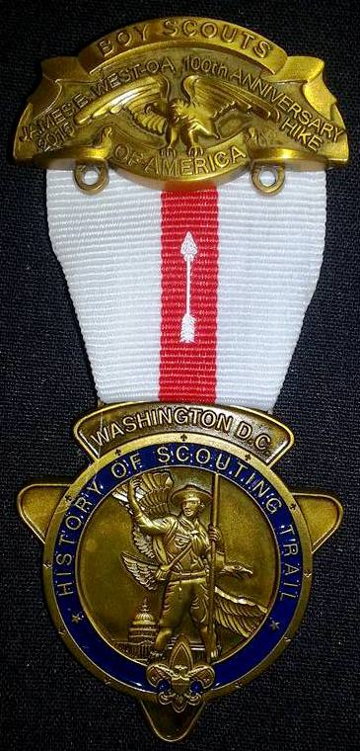
James E. West Hike
This 5.4 mile hike takes most units 4 to 5 hours to complete and the route takes you from the small park near the south side of the Air & Space Museum and ends at the National Museum of the American Indian.
The hike medal, and hike patches, will be available for purchase after being successfully earned by completing 85% or more of the activities associated with the hike. You will have the opportunity to redo activities if needed, in order to qualify you for your medal. There are only 3,000 Inaugural Medals available to hikers, once this number is reached, you will only be able to purchase a regular medal.
When you complete the HOST hikes, patches and medals are available at www.NCACBSA.org in the online store, or purchase at the Marriott Scout Service Center at 9190 Rockville Pike, Bethesda, MD 20814. An order can also be phoned in at 301-530-9360.

Where does it start?
The James E. West / OA 100th Centennial Hike starts at the south side of the Smithsonian Air and Space Museum and challenges lead you to additional stops.

Where does it end?
The hike ends at your last clue. From there, you can depart by any means desired.
What to bring on the hike? Each hiker (including adults) should have:
- Two pencils or pens
- A camera (each hiker must be able to take 6 photos individually, sharing is okay, cell phones with cameras are fine)
- Full Uniform (if you have one)
- 4 foot string or rope
- One empty plastic bag (supermarket type)
- Appropriate weather gear and water bottle
- Sunscreen
- Curiosity and sense of adventure
- Money to purchase Hike items at completion
- Compass
You’ll need at least one of these for the whole group:
- One crisp $1 bill (for one of the clues – you keep it)
- Small magnifying glass
- Binoculars (recommended)

