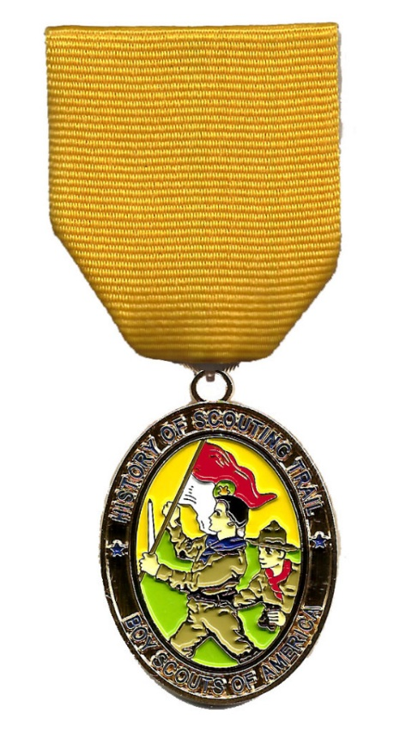
History Hike
This 2.5 mile hike takes most units 1–2 hours to complete and the route takes you from the National Geographic Museum and through the area around the White House.
The hike medal, and hike patches, will be available for purchase after being successfully earned by completing 85% or more of the activities associated with the hike. You will have the opportunity to redo activities if needed, in order to qualify you for your medal. When you complete the HOST hikes, patches and medals are available at www.NCACBSA.org in the online store, or purchase at the Marriott Scout Service Center at 9190 Rockville Pike, Bethesda, MD 20814. An order can also be phoned in at 301-530-9360.

Where does it start?
The History Hike starts in the courtyard of the National Geographic Building near 15th and M Street.
Where does it end?
The hike ends at the last at the last clue. Depart by any means desired at that point.

What to bring on the hike?
Each hiker (including adults) should have:
- Two pencils or pens
- A camera (each hiker must be able to take 6 photos individually, sharing is okay, cell phones with cameras are fine)
- Full Uniform (if you have one)
- A watch (any kind)
- One empty plastic bag (supermarket type)
- Appropriate weather gear and water bottle
- Sunscreen
- Curiosity and sense of adventure
- Money to purchase Hike items at completion
You’ll need at least one of these for the whole group:
- Compass
- Small magnifying glass
- One crisp $10 bill (for one of the clues – you keep it)
- Binoculars (Recommended)

