Come Join The Lions!
Lions is Scouting for Kindergarten-age Boys. Adventure awaits. Join today!

The program will fuel their imagination, creativity and fun as they experience the growth Scouting can provide. For highlights of Tufts University study on how Cub Scouts impacts character, see: http://www.scoutingnewsroom.org/press-releases/tufts-university-study-finds-boy-scouts-builds-positive-character/

A list of local Cub Packs below can be contacted to learn more and join:

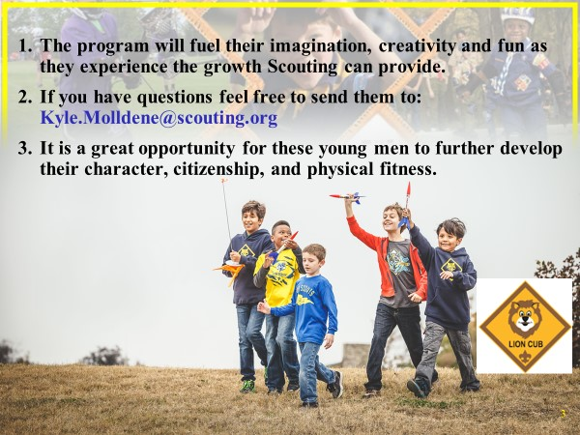
Pack 41, Bonnie Brae Elementary
Pack 50, Holy Spirit School
Pack 114, Shirley Gate Mosque
Pack 115, St Ambrose School
Pack 698, White Oaks Elementary
Pack 873, Parkwood Baptist Church
Pack 1101, Church of the Nativity
Pack 1131, St Stephens UMC
Pack 1344, Cherry Run Elementary School
Pack 1345, Terra Centre Elementary School
Pack 1346, Fairview Elementary School
Pack 1412, Redeeming Grace Church
Pack 1533, Mantua Elementary School
Pack 1534, Olde Creek Elementary School
Pack 1818, Congregation Olam-Tikvah
Pack 1864, Wakefield Forest Elementary School
Pack 1865, Oak View Elementary School
Pack 1965, Kings Glen Elementary School
Pack 1967, Robinson Secondary School
Pack 1968, Laurel Ridge Elementary School

For more information use your zip code in the below link:
https://beascout.scouting.org/

