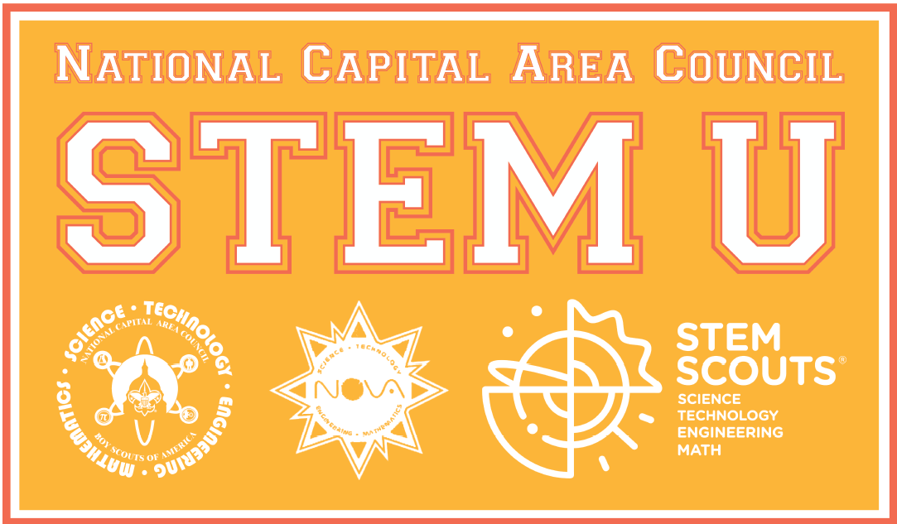

The NCAC STEM Committee is hosting the fourth annual STEM University and you are invited! The event includes a youth science fair, cub scout Supernova activities, Scouts BSA/Venturer Scout Nova activities, and adult leader trainings on STEM.
Date: Saturday, June 15, 2019 Location: MTC in Reston, VA
Who should attend? All Scouting leaders & all Youth!
Registration and further information: www.ncacbsa.org/stem

Adult leader classes will include: Supernova Mentor & Counselor training, STEM Scouts Lab orientation, Science activities for Cubs, Scouts BSA STEM and more!

Questions: email us at stem@ncacbsa.org

