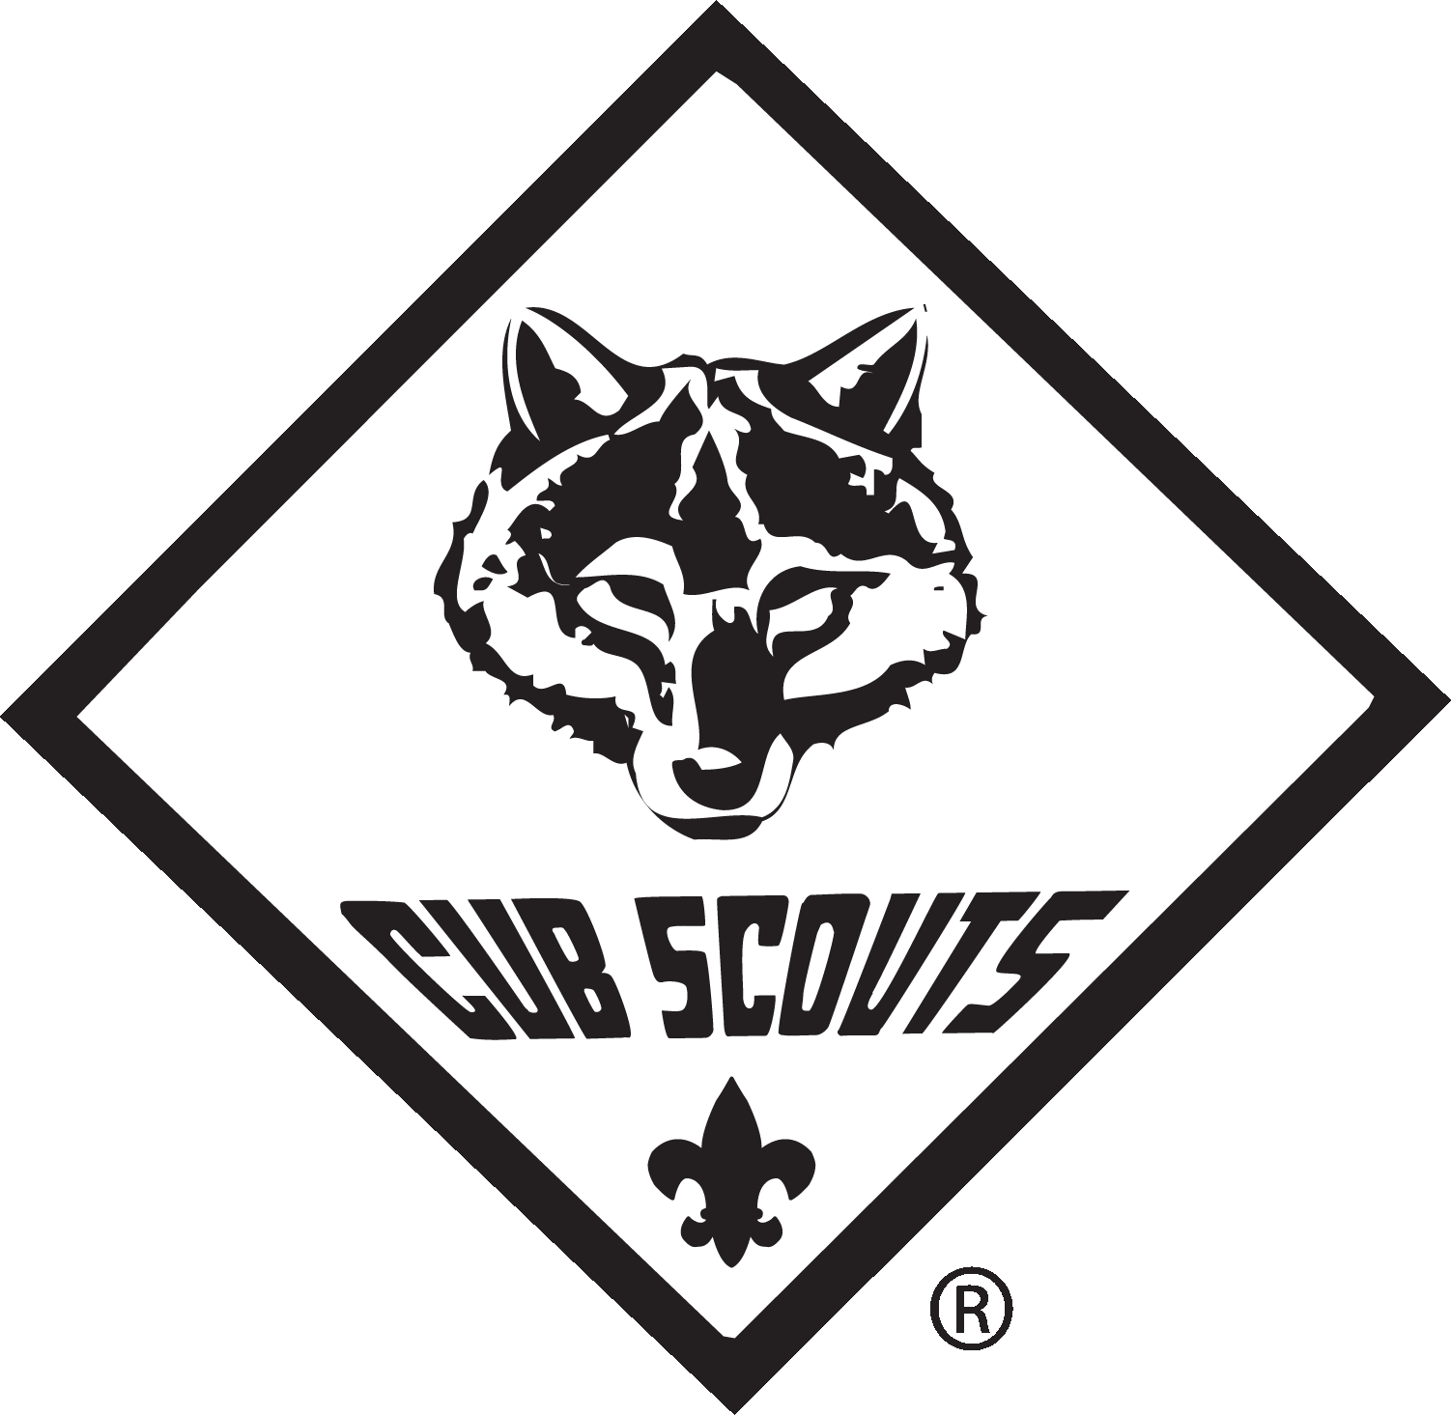
Pack Code of Conduct
Cub Scout Pack 492, Rockville, MD

Our Vision
Cub Scout Pack 492 aims to provide a safe, positive environment where our Cub Scouts can have fun while enjoying a family oriented program that builds character, teaches citizenship, and develops personal fitness.

It Takes a Pack to Succeed!
Succeeding in our vision requires the active support of all the members of our Pack, including our Cub Scouts, their parents or guardians, and our Scout Leaders. Our Code of Conduct sets the expectations for behavior at all Pack and Den functions out outlines what to expect if those expectations are not met. Parents or guardians should review this Code of Conduct with their Cub Scout(s) and returned the signed form to their Den Leader or Cubmaster.

Cub Scout Code of Conduct
As a Cub Scout of Pack 492, I promise to do my best to:
- Behave according to the Scout Oath and Scout Law at all times
- Behave according to my Den’s Code of Conduct at all times
- Listen to and obey my Den and Pack Leaders
- Leave any place we meet at for a Scouting activity better than I found it
While at the Church of Christ at Manor Woods, I promise to:
- Respect the property of the Church by not damaging the building, not eating Church food, and not touching Church equipment
- Only visit areas of the building that currently have a Den or Pack activity taking place
- Only use the stairs and not use the elevator
I understand that if I do not honor my promise:
- I will be warned that my behavior does not follow the Pack Code of Conduct
- After that, I will have a “time out” and miss part or all of a Den or Pack activity
- After that, I will need a parent or guardian to stay with me during future Den or Pack activities

Parent and Guardian Code of Conduct
As Parent or Guardian of a Cub Scout in Pack 492, I promise to:
- Support my Cub Scout’s efforts to advance in the Scouting program
- Work with Den and Pack Leaders to ensure all Cub Scouts follow the Code of Conduct
- Act as a positive role model, demonstrating proper behavior and language
- Volunteer and participate in Den and Pack activities to help the Pack succeed in its vision
- Not use alcohol or tobacco products while at Cub Scout functions, as required by BSA policy
- Respect the requirements of two-deep leadership and youth privacy protection at all times

Den and Pack Leader Code of Conduct
As a Den or Pack Leader of Cub Scout Pack 492, I promise to:
- Create a safe and positive environment for Cub Scouts during all Den and Pack activities
- Act as a role model, demonstrating proper behavior according to the Scout Oath and Scout Law
- Treat all Cub Scouts as individuals, respecting their unique needs and capabilities
- Complete and abide by Youth Protection Training and Leader Specific Training for my position

I have read the Pack 492 Code of Conduct and reviewed it with my Cub Scout(s):

___________________________________ ___________________________________
Parent or Guardian Printed Name Parent or Guardian Signature

_________________________________________________________________________________
Cub Scout Name(s)
The Scout Oath
On my honor I will do my best
to do my duty to God and my country and to obey the Scout Law;
to help other people at all times;
to keep myself physically strong, mentally awake, and morally straight.

The Scout Law
A Scout is
trustworthy, loyal,
helpful, friendly,
courteous, kind,
obedient, cheerful,
thrifty, brave,
clean, and reverent.

