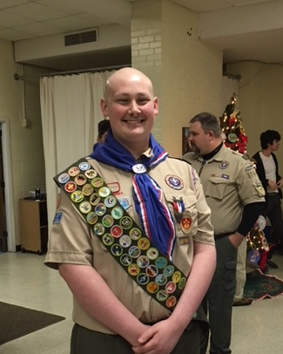  December 7, 2017  Fundraiser  David Robbins  Medical Fund  David Robbins, an Eagle Scout from BSA Troop 264, and graduate of Rockville High School Baccalaureate Program, has been fighting cancer since 2014. To help David and his family with the mounting medical bills, BSA Troop 264 Brookeville/Olney is sponsoring a fundraiser. Bring this flyer to Mamma Lucia on Dec. 7 and 20% of your total order will be donated to David’s Medical Fund.  Flyer MUST be presented and attached to each order. | Mamma Lucia’s Village Drive, Olney, MD  ────  12 pm to 10pm  ────  Bring this flyer to Mamma Lucia on Dec 7 for a 20% donation to David’s fund.  ────  Use this flyer for all dine-in, take out or delivery orders from  12 pm to 10 pm on Dec.7, 2017  ────  Gofundme.com/davidrobbins

