Goose Creek District
Freeze-O-Ree

February 8-10, 2019

Sponsored by:

GOOSE CREEK CHAPTER
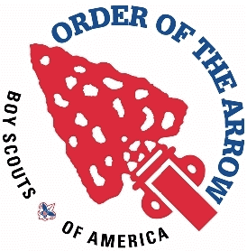
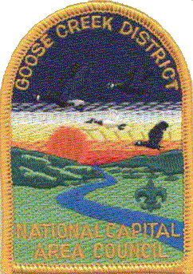
Order of the Arrow

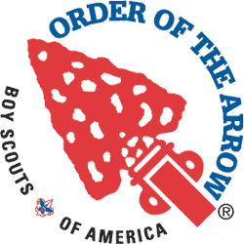

Dear Goose Creek District Unit Leader,
The 2019 Freeze-O-Ree is upon us. This year the event will be held the weekend of February 8th-10th, 2019 at Camp William B. Snyder. The cost per attendee is still only $16.
The Feeeze-O-Ree will have many opportunities for the participating patrols to compete in - and show off - their Scouting skills. Saturday evening will end with a campfire. Awards for the day's events will be presented at the campfire.
The activities for the Freeze-O-Ree will emphasize patrol teamwork, Scout skills and Scout spirit. Each patrol will be judged on their knowledge, performance and Scout spirit.
We have put together a fun filled schedule of events which will challenge the Scouts in many ways.
Scoutmasters and Senior Patrol Leaders are invited to attend the Cracker Barrel on Saturday night after the campfire at the camp headquarters.
The entire OA staff is looking forward to seeing you at this year's Freeze-O-Ree. If you have any questions, please contact the Goose Creek OA Chapter Adviser, Hal Raffensperger (hal.raffensperger@earthlink.net, or 703-717-2815).

Alex Stuck Than Horner
Alex Stuck Than Horner
Chapter Chief Vice Chief East
Goose Creek Chapter Goose Creek Chapter

Date: February 8th-10th, 2019
Place: Camp William B. Snyder; Haymarket, VA 20169
Cost: $16.00 per Scout/Adult. Unit Preregistration is MANDATORY, and all registrations must be received by February 3rd, 2019. NO REGISTRATIONS WILL BE ACCEPTED AFTER 2/3/2019.
Registration: Online Registration is to be done as a unit. Please have your event coordinator register the members of your unit prior to the deadline date. The registration link will be posted on the Goose Creek web site by January 18th. OA Members who wish to register as OA Staff and eat with the OA Staff must register individually as "OA Staff".
Vehicles: Vehicles and trailers will be permitted to go to the camp site for equipment drop off. All vehicles and trailers must then be parked in the Camp parking lot. Maximum speed limit in the Freeze-O-Ree area is 10 MPH. Any special vehicle parking requests must be preapproved by the camp staff.
Check In: Upon arrival at the Freeze-O-Ree, one adult Scouter and the Senior Patrol Leader from the unit must register at the headquarters pavilion (Handicraft Pavilion) and receive a campsite assignment
Check Out: Troops will not be permitted to leave until their campsite has been inspected by an Arrowman, and they have checked out with the Arrowman in charge.
Leadership: All units must be under the leadership of a registered Scouter over the age of 21 at all times. Each unit must insure that at least 2 adults are present with the unit while in the campground. Persons (Scouts and Scouters alike) leaving the camp ground at any time, other than at the end of the Freeze-O-Ree, must inform one of the OA advisers. No burning or smoldering fires will be left unattended at any time.
Health/Safety: The Boy Scouts of America prohibits the use of alcoholic beverages and controlled substances at encampments or activities on property owned and/or operated by the Boy Scouts of America, or at any activity involving participation of youth members. The use of tobacco products will not be permitted in the camp sites or in the Freeze-O-Ree activity areas.
Water: Water is available in the camping area.
Fire Wood: Firewood may not be brought to Camp Snyder. Firewood will be provided by the Camp.
Garbage: Pack out what you pack in. Your unit is required to remove all trash. Remember to leave your campsite better than you found it.
Bathrooms: The Camp's Bath Houses will be open for our use.
Participation: Competition and participation is expected to be by existing patrols, including Venturing or Leadership patrols. The formation of temporary "super patrols" for the purposes of winning Freeze-O-Ree events is strongly discouraged and not in the spirit of the activity. Existing patrols with very small numbers of participants who would otherwise not be able to participate in this activity may combine to form one patrol.
Awards: Points will be given for participation in both the field and skill events, extra points may be given in certain events for the patrols placing 1st, 2nd, or 3rd . Additional points will be given for camp setup, roster and menu posting, menu and dinner preparation, for patrol spirit and for campsite practices. Prizes will be awarded to the 3 highest total scores for the Freeze-O-Ree. A special patch has been designed by the Chapter Arrowmen for the Freeze-O-Ree. The patches will be distributed at the Boy Scout Roundtable in March 2018.
Campfires: FIRES can only be built in the campsite fire rings. DO NOT DIG ADDITIONAL FIRE PITS!
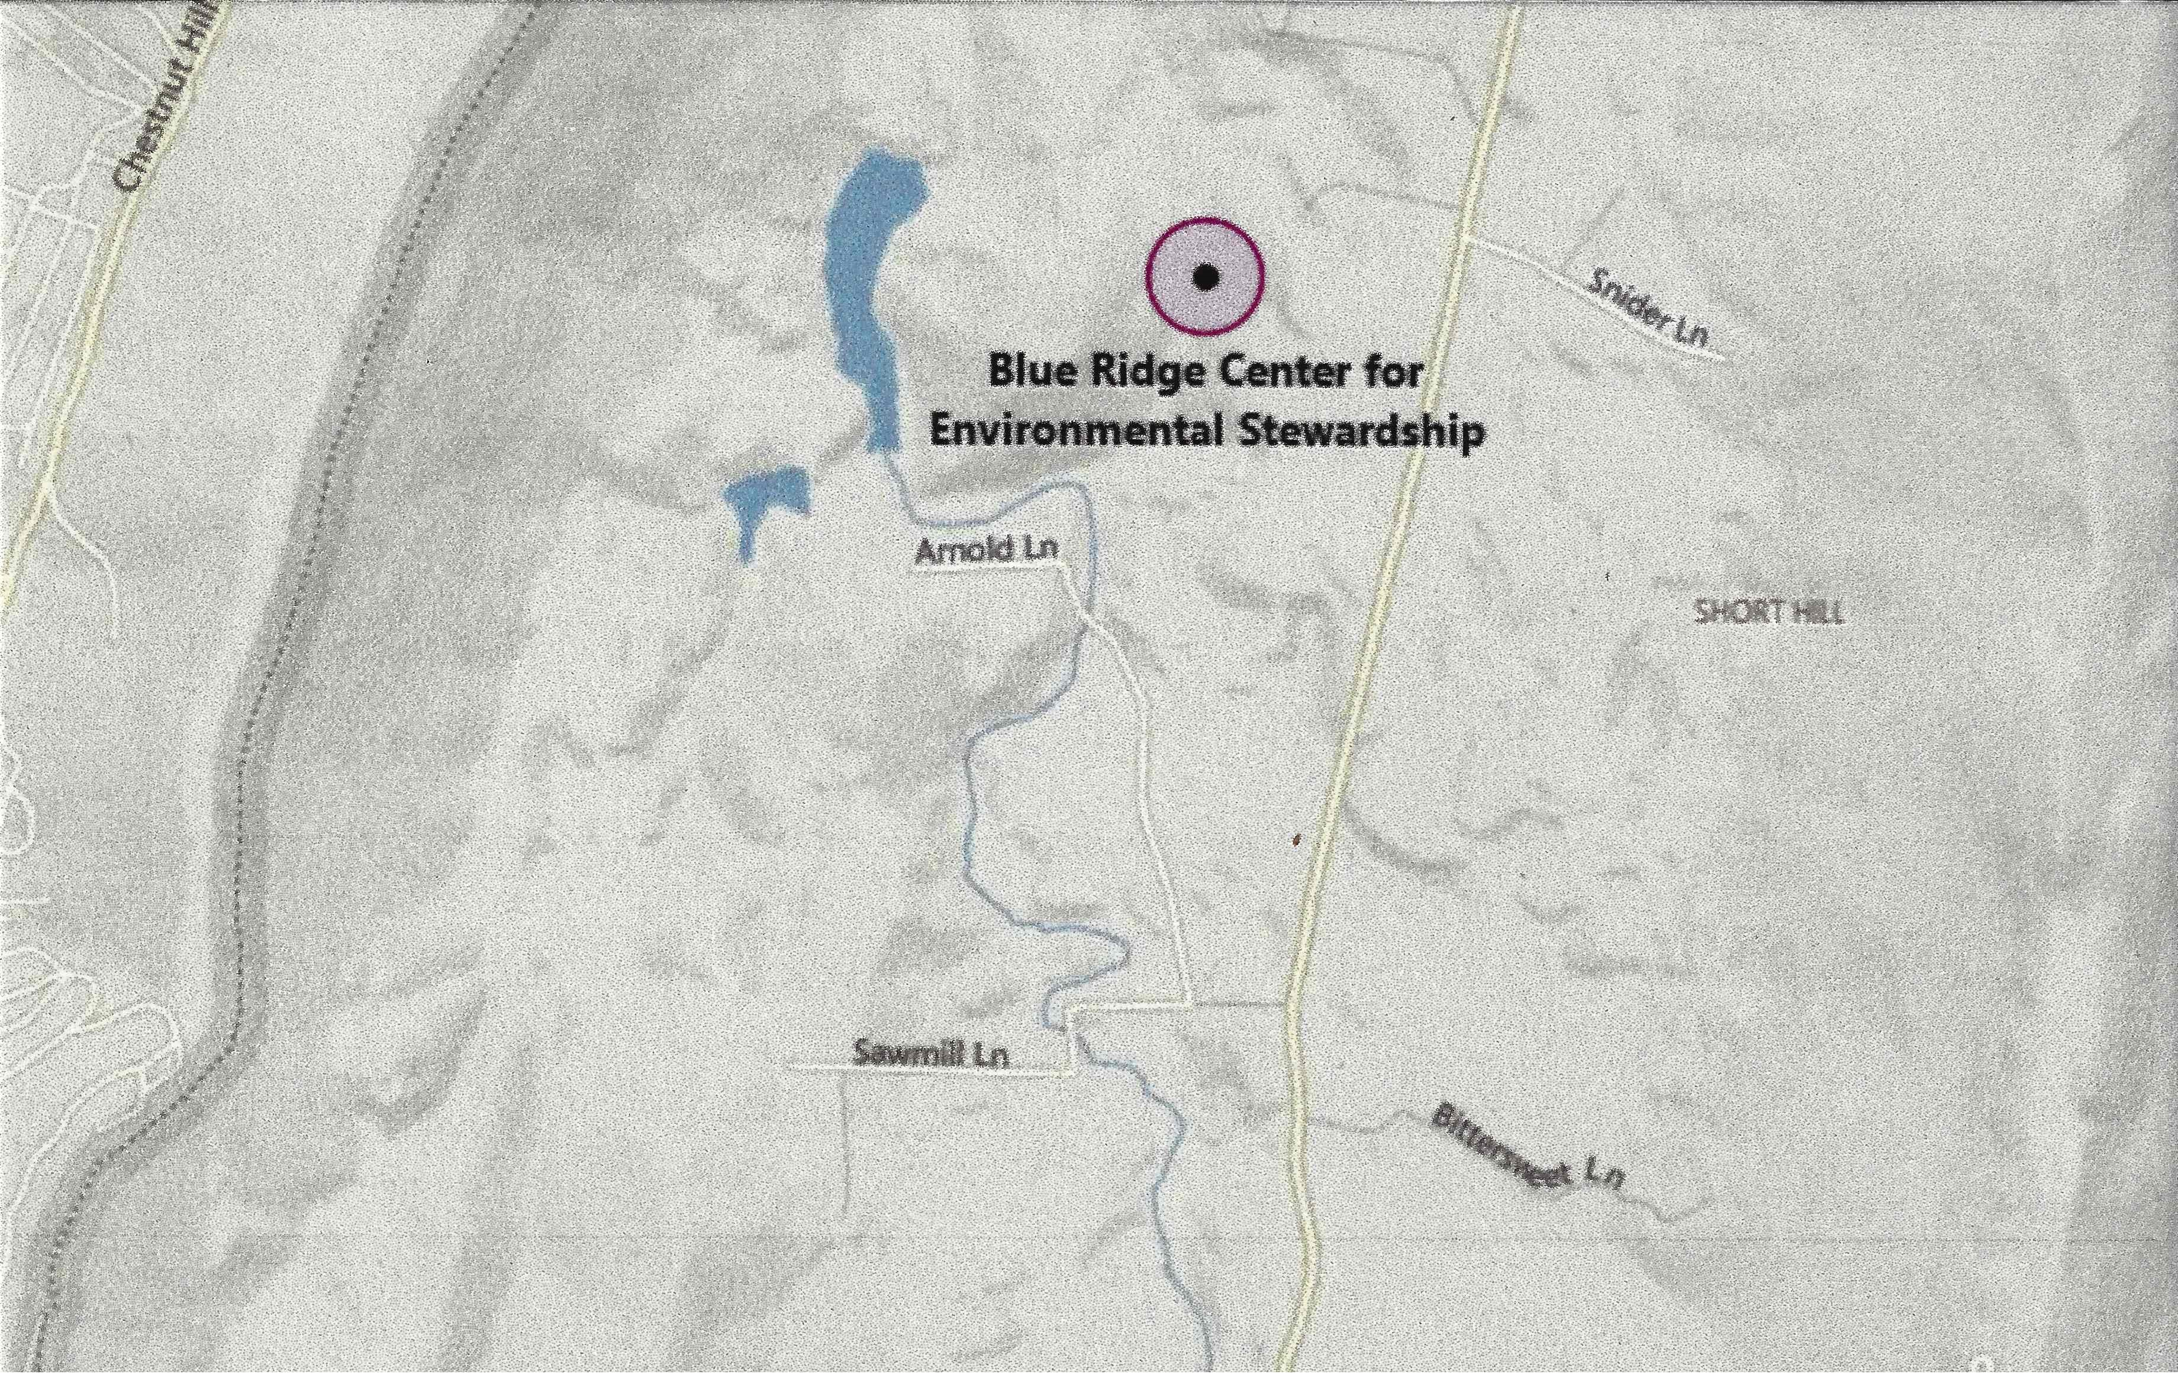
Freeze-O-Ree
Schedule of Events (subject to change)
Friday
6:30 PM-9:00 PM | Check-In & Registration. Turn in patrol registration forms at the camp
 | headquarters registration table/tent. Receive a campsite assignment. Move to
 | campsite and make camp.
9:30 PM | Scoutmaster/SPL Meeting at Camp Headquarters
11:00 PM | Taps for Scouts
Saturday
6:30 AM | Reveille
7:00 – 8:00 AM | Breakfast and Clean up Areas
8:00 AM | Patrol Event Schedules available at Camp HQ. Bring Pencil and Paper to write
 | down event schedules for your patrols. SM and SPLs only please.
8:00 AM | Registration begins for late arrivals. (Turn in patrol registration forms at the camp
 | headquarters registration table/tent. Receive a campsite assignment. Move to
 | campsite and make camp.)
9:00 AM | Opening Assembly, Flag Raising, Announcements
10:00 AM | Events begin (See schedule at HQ tent for your patrol starting times)
12:30 – 1:30 PM | Lunch
1:30 – 4:00 PM | Events Resume (See schedule at HQ tent for your patrol starting times)
4:30 – 6:30 PM | Dinner and Cleanup areas
6:30 – 7:00 PM | Chili Judging
7:15 – 7:45 PM | Dessert Judging
8:00 – 9:00 PM | Camp Fire & Awards … All OA MEMBERS WEAR YOUR SASH!
9:30 10:30 PM | Leader's Cracker Barrel
11:00 PM | Taps for Scouts
Sunday
7:00 AM | Reveille
7:00 8:30 AM | Breakfast
8:30 10:30 AM | Break Camp & Checkout (All units must check out with the OA before leaving
 | camp.) Every unit should be gone no later than 10:30am, so please plan accordingly.

Planned Activities
These are examples of the activities planned for the Freeze-O-Ree. However, this list is subject to change. To successfully run all of these events we need support from all of the troops. Each troop is expected to supply at least one youth OA member volunteer to participate as a staff member assistant and/or judge. The volunteer should plan on camping and eating with his troop. Because these Scouts will not be available to participate in events, additional points will be awarded to their Troop's score in recognition of their service. Very small troops, and those without OA youth members attending, may supply one adult. Arrowmen that wish to participate as a full time OA Staff Member, must contact the OA Chapter Adviser (hal.raffensperger@earthlink.net) or send an email to the Chapter Chief to obtain detailed information on registering as a Freeze-O-Ree Staff member.
Events without volunteer support, will not be conducted.
- Archery – Patrols will accumulate points according to points earned by all shooting.
- Fire Building – A fun and challenging activity that really tests to see if a Scout can make a fire big and high enough that will “burn the string” that is set horizontally to the fire and is tied between two sticks. Patrols will be asked to build a fire with only the materials provided
- First Aid – How good is your patrol at first aid? Can you recognize hypothermia? How about frost bite? How would you treat the symptoms? The questions will be taken from the Boy Scout Handbook, the answers are up to you!
- Football – Games will be a round robin, single elimination patrol event. The winner of each round will be the first team to score 3 points. The winner will be the first team to score 3 points or the one with the most points after 10 minutes of play, whichever comes first.
- Capture the Flag – Games will be a round robin, single elimination patrol event. Due to game scheduling.
- Slingshot Paintball – Points will be awarded by how accurate you are with the targets.
- Axe Throwing – If you think you are a real Mountain Man, try this activity. The goal here is simple “Hit the Target”, it is not as easy as it looks!
- Knot Tying - If you know knots, they you will win big. Points awarded for successfully tying requested knots.
- "The Great Goose Creek Freeze-O-Ree Chili Cookoff" – A chili dish of your choosing may be submitted for judging. This is to be part of your Saturday evening dinner, and to be considered for judging, you should bring a bowl of your chili to the OA camping headquarters. Your dish may win you first place; however, only participation is included in the Freeze-O-Ree score. Judging will include taste, texture, presentation, etc.
- "A Freeze-O-Ree Dessert Competition" – A dessert dish of your choosing may be submitted for judging. This is to be part of your Saturday evening dinner. To be considered for judging, you should bring a bowl/dish of your dessert to the OA camping headquarters. Your dish may win you first place; however, only participation is included in the Freeze-O-Ree score. Judging will be based on taste.

- Tug of War – 2 troops at a time will face off with each other in a battle of brute strength.
Freeze-O-Ree Score Sheet (SAMPLE)
THIS IS A SAMPLE FORM – Actual forms will be distributed at the FREEZE-O-REE !
Troop ________ Patrol: _____________________________________________________
Troop Points Possible Actual
- Troop Flag Displayed 50
- First Aid Kit 75
- Youth Leadership is evident 75

First Patrol Inspection (Site Inspection)
- Menu and roster posted 25
- Meals are proper for weather 25
- Campsite is neat and orderly 25
- Water visibly present 25

Second Patrol Inspection (Activity start)
- Scouts are properly dressed (for the weather) 50
- Patrol Flag 20
- Scout Handbook 20
- Pencil and Paper 10

Event Participation Points 600
Total Possible 1,000

PATROL LEADERS MUST HAVE THIS SHEET WITH THEM FOR ALL EVENTS AND INSPECTIONS

THIS IS A SAMPLE FORM – Actual forms will be distributed at the FREEZE-O-REE !
Individual Patrol Score Sheet:
THIS IS A DRAFT ACTIVITY LISTING & SCORE SHEET Actual forms will be distributed at the FREEZE-O-REE !
This score sheet must be turned in at the OA HQ tent when you complete your last challenge event for your scores to be counted. Each patrol must turn in their own score sheet.
Troop _______ Patrol Name: _______________________________________________
Real Score Sheet In google docs
Event # | Event Name | Max Points | Point Score | Elapsed Time: (If timed event) | Judges Initials
Event 1 | Archery | 50
Event 2 | Fire Building | 50
Event 3 | First Aid | 30
Event 4 | Football: 25 participation, 50 championship game, 100 champion | 100
Event 5 | Capture the Flag: 25 participation, 50 championship game, 100 champion | 100
Event 6 | Slingshot paintball | 50
Event 7 | Axe Throwing | 50
Event 8 | Knots | 50
Event 9 | Chili Cookoff Participation | 50
Event 10 | Dessert Contest Participation | 50
 | Total Score: | 600

UNIT COPY (POST IN CAMP – ONE FORM PER PATROL)
PATROL___________________________________ TROOP___________________________

PATROL DUTY ROSTER
 | Friday Dinner | Saturday Breakfast | Saturday Lunch | Saturday Dinner | Sunday Breakfast
Patrol Leader
Asst Patrol Leader
Cook
Asst Cook
Water
Dishwasher
Clean Up

PATROL MENU
Notes | Friday Dinner | Saturday Breakfast | Saturday Lunch | Saturday Dinner | Sunday Breakfast
PATROL ROSTER (one per patrol)
UNIT COPY (POST IN CAMP)

PATROL NAME:
PATROL MEMBERS NAMES | AGE | RANK
PL =
SPL =
SCOUTMASTER: | SPL:

PATROL REGISTRATION
REGISTRARS COPY (Turn in at Registration)

PATROL NAME:
PATROL MEMBERS NAMES | AGE | RANK
PL =
SPL =
SCOUTMASTER: | SPL:

