George Mason District Scouts in Service on Memorial Day 2020
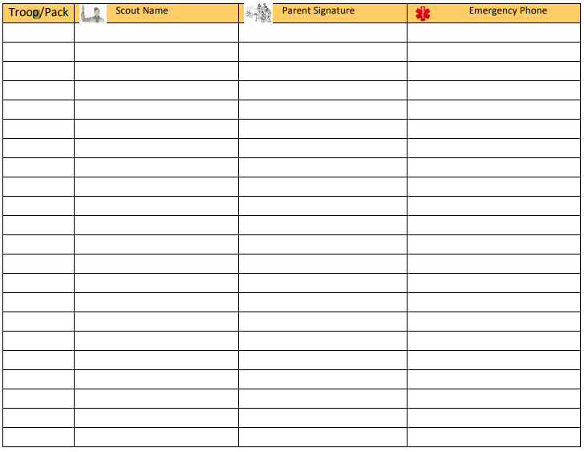
HOLD HARMLESS AGREEMENT
I understand that participation in scouting activities involves a certain degree of risk and can be physically, mentally, and emotionally demanding. I have carefully considered the risk involved and have given my consent for myself or my child to participate in this activity. I also understand that participation in this activity is entirely voluntary and requires participants to abide by applicable rules and standards of conduct. I give my permission as a parent or legal guardian for the Scout/Youth name below to participate in this activity. I understand that the organizers take reasonable and prudent precautions to minimize risks to participating scouts, but that it is not possible to eliminate all risk of mishap or injury. I release the Boy Scouts of America, the National Capital Area Council, it’s sponsoring organization the activity coordinators, and all employees, volunteers, related parties, or other organizations associated with the activity from any and all claims or liability arising out of this participation. I give my permission for the adult leaders responsible for this activity to authorize emergency medical treatment for the Scout in my absence should they deem it necessary to do so and to provide over-the-counter medications, sunscreen and insect repellent.

In case of emergency involving my child, I understand every effort will be made to contact me. In the event I cannot be reached, I hereby give my permission to the medical provider selected by the adult leader in charge to secure proper treatment, including hospitalization, anesthesia, surgery, or injections of medication for my child. Medical providers are authorized to disclose to the adult in charge examination findings, test results, and treatment provided for purposes of medical evaluation of the participant, follow-up and communication with the participant's parents or guardian, and/or determination of the participant’s ability to continue in the program activities.

